ICT Engineering

SEP 1Y A16

Project Report

Group 1

Andreea Buturca 253691

Karolina Beliharova 253810

Marek Lowy 253652

Martin Janosik 253934

Supervisors

Steffen Vissing Andersen

Birgitte von Fyren Balsløv

Date: 16. 12. 2016

**Table of contents**

1 Introduction 5

2 Analysis 6

2.1 Requirements 6

2.2 Use Case Diagram 8

2.3 Use Case Description 10

2.4 Activity Diagram 11

3 Design 12

3.1 Graphical User Interface (GUI) 12

3.2 Model class diagram 15

3.3 Class diagram 16

3.3.1 Class Diagram Breakdown 17

3.4 Sequence diagram 18

19

4 Implementation 20

5 Testing 44

6 Results 49

7 Conclusion 50

8 References 51

8.1 Books 51

8.2 Additional resources 51

9 Appendices 52

9.1 Appendix 1 – Activity diagram 52

9.2 Appendix 2 – Use Case Description 56

9.3 Appendix 3 – Class Diagram 63

9.4 Appendix 4 – User Guide 64

**List of figures and tables**

Figure 1: Priority Use Case Diagram 8

Figure 2: Create Tour 11

Figure 3: Making GUI 1 12

Figure 4: Making GUI 2 13

Figure 5: Making GUI 3 13

Figure 6: Making GUI 4 14

Figure 7: Class Diagram 16

Figure 8: Sequence Diagram 19

Table 1: Create Tour 10

Table 2: Class Diagram Breakdown 17

**Abstract**

*VIA Bus is a company located in Horsens, Denmark with Trip Driver as the manager. At VIA Bus, you can either rent a bus with a chauffeur – driving to a destination of your choice, or travel by bus to one of the predefined locations, i.e. a few European countries and some Danish sites and events.*

*VIA Bus needs a system to keep track of the tours, chauffeurs, bus routes and customers, and therefore the manager Trip Driver decided to contact us to create it. The system is based on Java and meets the requirements of the customer. The system is user friendly, can be used by any employee of the company, it contains menus, tabs, lists and buttons exactly as Trip Driver required. There are several options in the main menu. User can choose between making new reservation, creating tour, finding reservation or tour in the system, adding busses or chauffeurs.*

*One of the main tasks is creating tour. Each tour can be created for a certain number of people. The number is assigned to that specific tour and depends on the bus type. The customer can be chosen for private tour, and also a date interval, destination, stops, bus type, and chauffeur.*

# Introduction

The project presented is based on an interview with VIA Bus Company that offers different types of tours for customers. They organize predefined trips and travels and make new trips by renting a bus with a chauffeur. The company is in need for a better system to monitor, record and organize all the services they offer.

The system must meet VIA Bus requirements, run on Java, which means it must be used on various platforms. Simple and usability tested, GUI must be implemented to make sure that the employees will have no problems using it. It must be a single user system, running on one single front desk.

The VIA Bus company needs a powerful tool that will handle every aspect which the employees might encounter. The system must be implemented simple, and must handle all reservations, trips and travels, to keep track of all the tours, chauffeurs must be able to manage prices for each reservation, prices for extra services, discounts. The system will automatically calculate prices for each reservation according to travel type, extra services, to create new tours and reservations, edit, cancel and remove them at any given time. Also it must be possible to register new chauffeurs as temps, when needed. The employees must find all available chauffeurs and busses, to assign them new tours according to their preferences and also must keep track of chauffeurs while they are on route. All the data has to be saved in computer using database which will be easy to back up in case of losing data.

The system is developed on requirements, use case descriptions and diagram, activity, class and sequence diagram, followed by implementation, test parts, giving clear and accurate results.

# Analysis

## Requirements

1. The employee should be able to search through the list of destinations for the two kinds of tours: standard trips and travels, and private trips and travels with a private bus and a chauffeur.
2. The employee should be able to see all available seats for each tour.
3. The employee should be able to make a reservation for available seats for given destination, date, and time.
4. The employee should be able to see details about reservation as price, extra services, discount, amount of passengers, customer’s name, address, email, phone number, the number of points given to each customer, passenger’s name, birthday, destination, departure time and date, bus type and chauffeur’s dates.
5. For private customers, the employee should be able to register the name, address, the passenger’s birthday, and when it is permitted the email address for the newsletter.
6. For companies, the employee should be able to register the name, address, phone number of the person that is making the reservation and the company’s name.
7. The employee should be able to identify the profile customer: company or private person, including at least name, address, email, and phone number.
8. The employee should be able to find data about customer in the list of customers, to check the number of points and if it’s a frequent customer.
9. The employee should be able to register chauffeurs by: name, address, email, phone, date of birthday, employee ID, preferences for tour distance: long, medium, short, for bus type: classic, mini, party luxury.
10. The employee should be able to identify the chauffeurs with full time contract and temps.
11. The employee should be able to see all the details about the chauffeurs in the list of chauffeur.
12. The employee should be able to register all the busses by selecting the type: classic, mini, party luxury, registering the number plates and number of seats per bus.
13. The employee should be able to see all the details about the busses in the list of busses
14. The employee must be able to register the hour, date and place for the tours’ arrival, departure and stops.
15. The employee should be able, in creating tour, to select which bus is available for next tour, selecting in the list of busses one bus type.
16. The employee should be able to find an available chauffeur after the suitable bus was found and time and date for the tour were chosen.
17. The employee should be able to search through the list of chauffeurs: full time or temps.
18. The employee should be able to hire a bus-and-chauffeur, for a private tour, after searching through the list of tours.
19. The employee should be able to add extra services such as: food, accommodation, tickets, suitable for the private tours, according to customer requirements.
20. The employee must be able to find, edit or remove the tours.
21. The employee must be able to find, edit or remove the reservations.
22. The employee should be able to add additional notes for each reservation, in order to set the correct price for each customer.
23. The employee should be able to set the prices for extra services for each reservation according to passenger’s age.
24. The employee should be able to set a lower price for extra services for persons under 18.
25. The employee should be able to reward and give discounts to customers before setting the total price.
26. The employee should be able to save reservation if there are some changes.
27. The system stores all the data in database.
28. The system must be implemented in Java

## C:\Users\Karolina\Desktop\SEP\usecase.PNGUse Case Diagram

Figure 1: Priority Use Case Diagram

**Tours Overview:** All tours will be shown sorted by current date.

**Create tour:** The Employee is asked to enter information about the new tour: date, time, departure, destination, distance, he must choose a bus from the bus list and a chauffeur from the chauffeur list, fill in extra services, price, bus stop and time for break. If it is a private tour, the employee must fill data about customer, otherwise the tour is added to the list like a standard tour.

**Register a new chauffeur:** The Employee is asked to enter information about the new chauffeur using the following parameters: name, address, phone number, email address, employee ID (5-digit number), and type of contract: full-time or vicar. If it is full-time, the employee can specify wishes for bus, distance and the chauffeur is added to the list

**Manage buses:** The employee is asked to enter information about the new bus: type, registration plate and number of seats and the bus is added to the list. The employee is able to remove the bus from the list.

**Make reservation:** Theemployee can make a reservation, adding the customer and the passengers, setting the price for extra services, according to passenger’s age, and discounts.

**Find Reservation/Tour:** Theemployee can search a reservation by customer data: name / company name, address, email and phone number. The employee is able to remove a reservation, can find a tour by searching with the following parameters: destination, departure, date, and is able to remove a tour from the list.

**Edit reservation/tour:** The employee can change any information about reservation/tour.

## Use Case Description

“Create tour” is the most important part of the system because the purpose of this project is to develop a system that rents a bus with a chauffeur driving to a destination of customer’s choice, or travel by bus to one of the predefined locations. The documentation for all other classes and Use Cases can be found in the appendices. The following pages of the documentation (sequence diagram, activity diagram, and implementation) will be orientated to the “Create tour” use case.

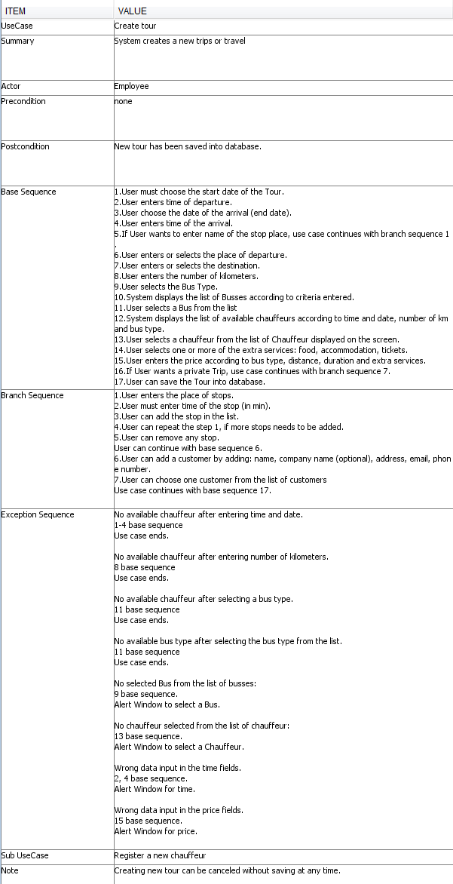Check appendix 2 – Use Case Descriptions

Table 1: Create Tour

## Activity Diagram

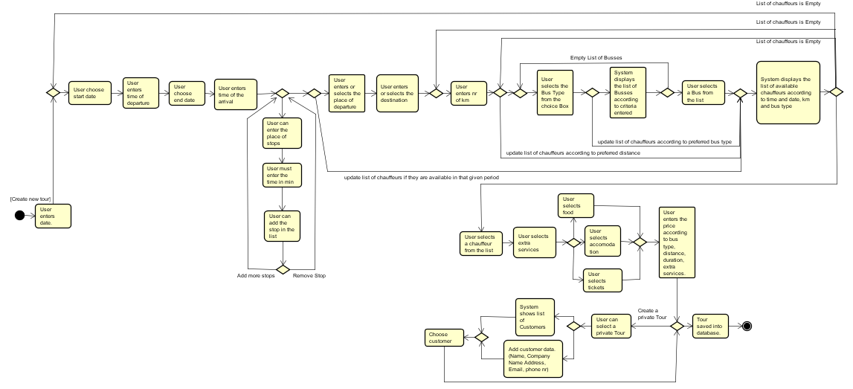The Create tour activity diagram displays step-by-step the process of creating new tour. The special thing about this use case is that the user can create a standard tour, which will appear in the list of tours and can be used for later reservations and in the same time, the user, can create a private tour, by renting a bus and a chauffeur for only one use, assigning it to a customer. Everything said it is shown in the diagram bellow.

Figure 2: Create Tour

Check appendix 1 – Activity diagrams.

# Design

## Graphical User Interface (GUI)

In the beginning of the GUI implementation, the sketch was drawn on the paper, and that helped to understand better what the system must consists of. It was created a simple interface in JavaFX, in which it was used text fields, combo boxes, buttons, lists, radio buttons, check boxes, date picker, choice boxes.

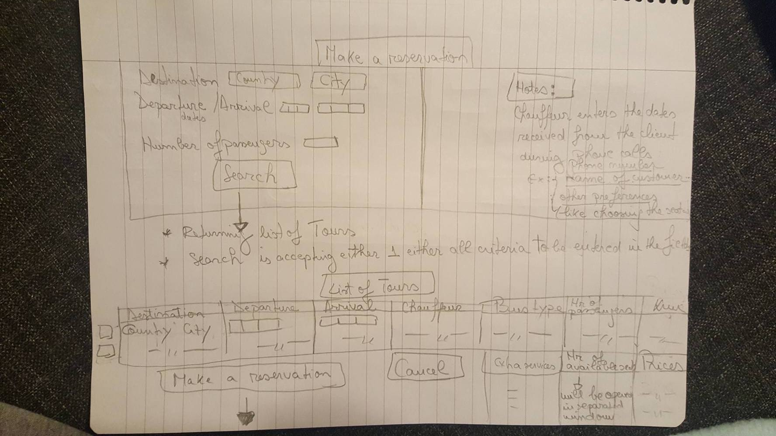 One of the most important method from the program is “Make reservation”. This method was designed on two pages, each representing a step. In first step, GUI was build taking into consideration that the user must search through the list of Tours, for the trip or travel, that customer needs to reserve. As seen in the picture bellow at this step it was used in implementation a text area for notes, 3 text fields for searching, and a list to display the tours.

Figure 3: Making GUI 1

In the second step, GUI was developed so the user could enter the dates about the customer, passengers, price for extra services and discount. The user can make a reservation by selecting the customer, passengers from the lists. So, it was used 2 lists, date picker for birthday, and text fields to enter the dates.

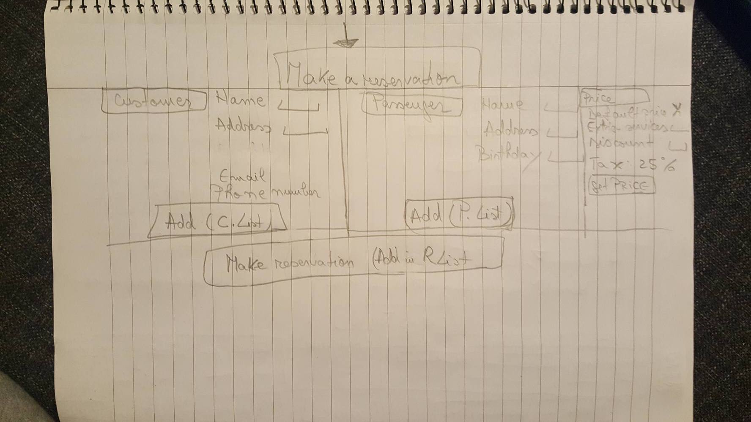

Figure 4: Making GUI 2

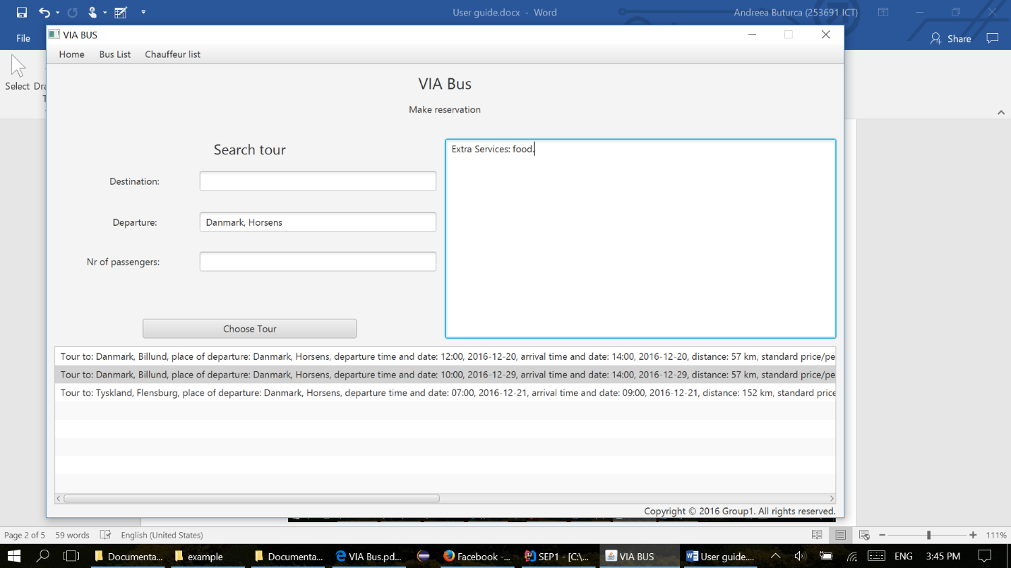The result looks a little different, as they are better organized and implemented in JavaFX. It must be mentioned that, after clicking Choose Tour, the notes from first step will automatically appear in the second step of making reservation, with the same data, only if the user typed into the note section. Notes are a convenient way of storing information which the user needs in the workspace.

Figure 5: Making GUI 3

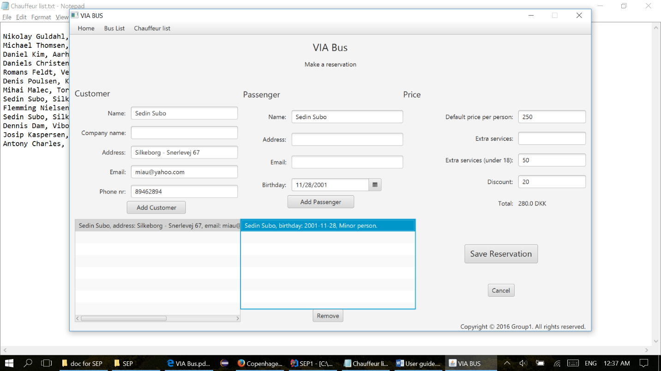

Figure 6: Making GUI 4

Check appendix 4 – User Guide

## Model class diagram

This basic model shows us the structure of the system. The abstract class “Bus” is used to handle all information’s about the bus in the system such as registration plate and seat places, and through this class we get information about bus type from classes “LuxuryBus, PartyBus, ClassicBus, MiniBus”. The “Bus list” class stores all busses and information about them. The “Person” abstract class is extended by classes “Passenger, Customer, and Chauffeur” and is used to store data about them. “ChauffeurList” is used to hold a list of chauffeurs and it can sort chauffeurs according to their, availability, preferences for bus, distance. “CustomerList” is used to hold a list of customers and sort them according to find criteria and the same is for “PassengerList” with passengers. Every object of class “Reservation” stores information about each reservation. “ReservationList” is used to hold a list of reservation and it can filter them by customer’s dates. Information in class “Destination” is about place and stops and it is stored to “DestinationList”. In class “Trip” is created new tour and all data is saved to “TripList”, also the class TripController is responsible for creating tours. The Class Controller is responsible for verification of all the data. The class “Main” contains a main void function, helping to launch the system. The class “DataHandler” is used for connecting database with the “Main” class and helps us to have fixed connection with database when we do some changes like add bus/reservation/chauffeur.

## Class diagram

Figure 7: Class Diagram

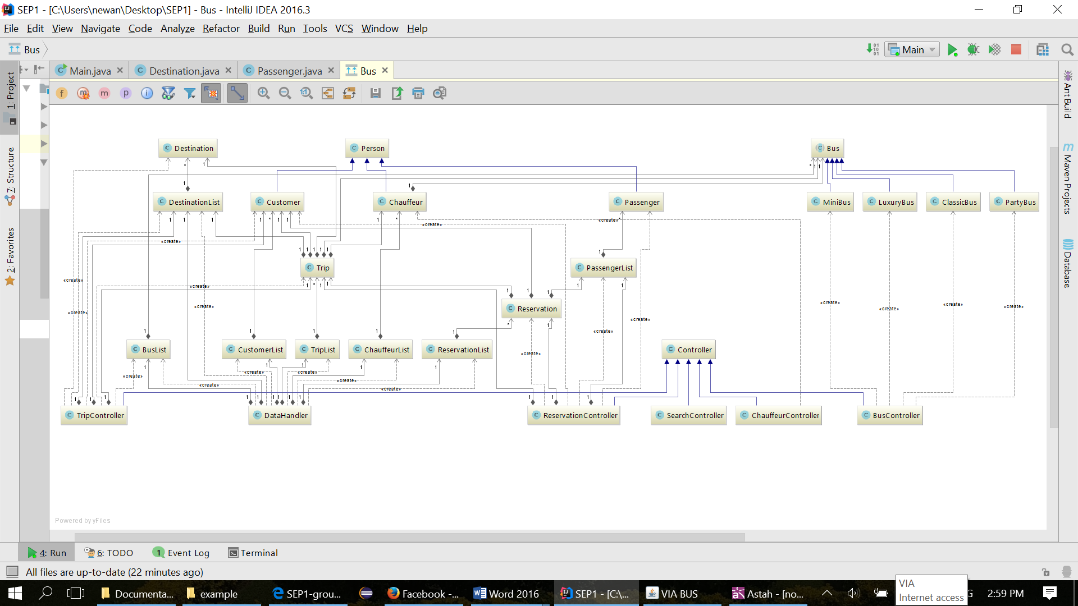Check appendix 3 – For extended Class Diagram

### Class Diagram Breakdown

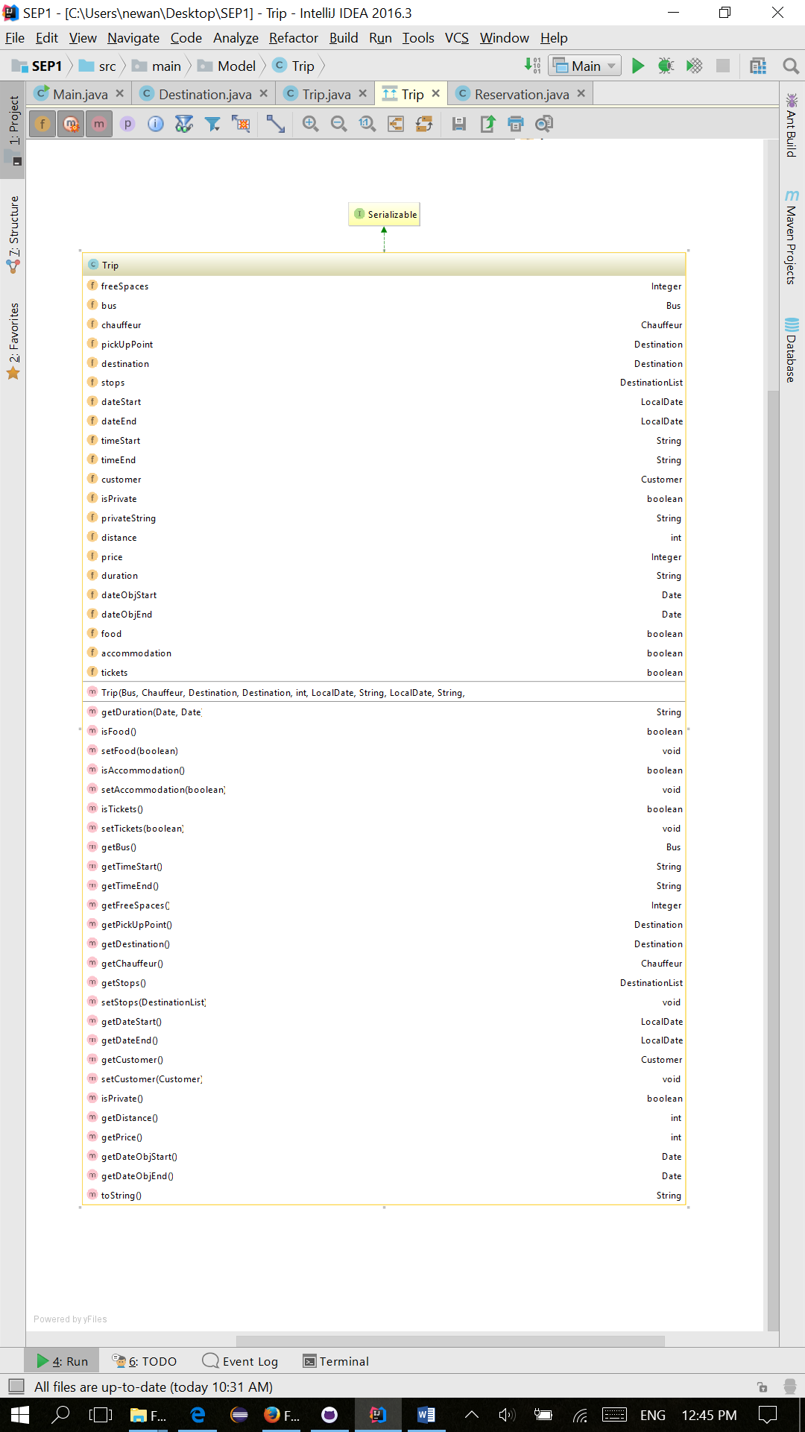One of the most important part of our program was to create new trip. In the Trip class, the user must specify all the dates needed to create a trip: the time – start and end (String variables), the date of the trip (taking variables of type LocalDate), the departure, the destination (from Destination class), the distance (integer), the bus type (Class Bus), the chauffeur (Class Chauffeur), available places and possibly extra services (food, accommodation, tickets - Booleans) and stops (Class DestinationList). At the end, the price is specified. The class has as methods getters for each instance variable, for extra services Booleans - getters and setters, for customer and the stops - setters. To return a proper format for the tours, the method toString returns the Booleans for extra services and for private tour, only if they are true, in String format. Also, it checks if there are stops during the tour and returns if they are tru. The method setCustomer is used only for private tours and assigns a customer to the trip, also it assigns the free places to 0, because a customer it’s supposed to rent a full bus.

Table 2: Class Diagram Breakdown

## Sequence diagram

The sequence diagram shows process of creating new tour. Firstly, data about dates and places of departure and destination are entered. After entering distance and bus type, available chauffeurs are found and shown and then available buses are found the same way. Then extra services, bus, chauffeur are picked and price entered. At the end the stops can be entered one by one, by entering place of stop and time. After user decided to create tour the data is validated and if some mistakes occurred, alert is shown. Then trip is created with entered data and saved to list of trips. User is shown success dialog.

# C:\Users\Karolina\Desktop\SEP\sequence.PNG

Figure 8: Sequence Diagram

# Implementation

One of the most important part of our program was to create new trip/tour.

In order to create a new tour the user has to specify dates, time, departure, destination, distance, bus type and possibly extra services and stops. At the end the price is specified. The tour is created by clicking on button create tour.

package main.Controller;  
  
import javafx.collections.FXCollections;  
import javafx.collections.ObservableList;  
import javafx.event.ActionEvent;  
import javafx.fxml.FXMLLoader;  
import javafx.fxml.Initializable;  
import javafx.scene.Parent;  
import javafx.scene.Scene;  
import javafx.scene.control.*;  
import javafx.scene.input.KeyEvent;  
import javafx.stage.Modality;  
import javafx.stage.Stage;  
import main.Main;  
import main.Model.*;  
  
import java.io.IOException;  
import java.net.URL;  
import java.util.Date;  
import java.util.ResourceBundle;  
  
*/**  
 * Class that manages trips.  
 *  
 \** ***@author*** *IT-1Y-A16 Group 1  
 */*public class TripController extends Controller implements Initializable {  
  
  
 public TextField fieldStartTime;  
 public TextField fieldEndTime;  
 public ComboBox fieldDestination;  
 public ComboBox fieldDeparture;  
 public TextField fieldDistance;

public TextField fieldPrice;  
 public DatePicker startDatePicker;  
 public DatePicker endDatePicker;  
 public CheckBox checkPrivateTrip;  
 public Button CreateTourBtn;  
 public ListView busListview;  
 public ChoiceBox busType;  
 public ComboBox stopName;  
 public Button addStopBtn;  
 public Button removeStopBtn;  
 public ListView stopsList;  
 public TextField stopTimeField;  
 public ListView chauffeurList;  
 public CheckBox foodCheckBox;  
 public CheckBox accommodationCheckBox;  
 public CheckBox ticketCheckBox;  
  
 //Add customer  
 public TextField fieldCustomerName;  
 public TextField fieldCustomerCompany;  
 public TextField fieldCustomerAddress;  
 public TextField fieldCustomerEmail;  
 public TextField fieldCustomerPhone;  
 public ListView customerList;  
 public Button saveCustomerBtn;  
 public Label tourLabel;  
 private Customer customer = null;  
 private TripController mainController;  
  
 //list for stops  
 private DestinationList stops = new DestinationList();  
  
 private Trip oldTrip;  
  
  
 @Override  
 public void initialize(URL location, ResourceBundle resources) {  
  
 if (fieldStartTime != null) {  
 loadBusList();  
 loadChauffeurList();  
  
 ObservableList<Destination> destinationItems = FXCollections.*observableArrayList*();

destinationItems.addAll(DataHandler.*getDestinationList*().getArrayDestination());  
 fieldDestination.setItems(destinationItems);  
 fieldDeparture.setItems(destinationItems);  
 stopName.setItems(destinationItems);  
 }  
  
 if (customerList != null) loadCustomerList();  
  
 }  
  
 public void getDataChoice(ActionEvent actionEvent) {  
 loadBusList();  
 loadChauffeurList();  
 }  
  
 public void getDataFromField(KeyEvent keyEvent) {  
 loadBusList();  
 loadChauffeurList();  
 }  
  
 public void callCustomerList(KeyEvent keyEvent) {  
 loadCustomerList();  
 }  
  
 private void loadChauffeurList() {  
 ChauffeurList chauffeurs;  
  
 chauffeurs = DataHandler.*getChauffeurList*().copy();  
 chauffeurs.removeAllVicars();  
  
 if (validateEmptyField(fieldDistance) && validateNumberField(fieldDistance)) {  
 chauffeurs = chauffeurs.getAllByPrefferedDistance(Integer.*parseInt*(fieldDistance.getText()));  
 }  
 chauffeurs = chauffeurs.getAllByPrefferedBus(busType.getValue().toString());  
  
 for (Chauffeur chauffeur : DataHandler.*getChauffeurList*().getAllVicars().getArrayChauffeur()) {  
 chauffeurs.add(chauffeur);  
 }

if (startDatePicker.getValue() != null && endDatePicker.getValue() != null && validateTimeField(fieldStartTime) && validateTimeField(fieldEndTime)) {  
 String[] lineToken = fieldStartTime.getText().split(":");  
 int hours = Integer.*parseInt*(lineToken[0]);  
 int minutes = Integer.*parseInt*(lineToken[1]);  
 Date dateStart = new Date(startDatePicker.getValue().getYear() - 1900, startDatePicker.getValue().getMonthValue(), startDatePicker.getValue().getDayOfMonth(), hours, minutes);  
 lineToken = fieldEndTime.getText().split(":");  
 hours = Integer.*parseInt*(lineToken[0]);  
 minutes = Integer.*parseInt*(lineToken[1]);  
 Date dateEnd = new Date(endDatePicker.getValue().getYear() - 1900, endDatePicker.getValue().getMonthValue(), endDatePicker.getValue().getDayOfMonth(), hours, minutes);  
 chauffeurs = chauffeurs.getAvailable(dateStart, dateEnd);  
 }  
  
 chauffeurList.getSelectionModel().setSelectionMode(SelectionMode.*SINGLE*);  
 ObservableList<Chauffeur> items = FXCollections.*observableArrayList*();  
 if (chauffeurs.getSize() != 0) {  
 items.addAll(chauffeurs.getArrayChauffeur());  
 }  
 chauffeurList.setItems(items);  
 }  
  
 private void loadBusList() {  
  
 BusList buses;  
  
 if (busType.getValue().equals("Mini Bus"))  
 buses = new BusList(DataHandler.*getBusList*().searchByType("main.Model.MiniBus"));  
 else if (busType.getValue().equals("Party Bus"))  
 buses = new BusList(DataHandler.*getBusList*().searchByType("main.Model.PartyBus"));  
 else if (busType.getValue().equals("Luxury Bus"))  
 buses = new BusList(DataHandler.*getBusList*().searchByType("main.Model.LuxuryBus"));  
 else buses = new BusList(DataHandler.*getBusList*().searchByType("main.Model.ClassicBus"));  
  
 if (startDatePicker.getValue() != null && endDatePicker.getValue() != null && validateTimeField(fieldStartTime) && validateTimeField(fieldEndTime)) {  
 String[] lineToken = fieldStartTime.getText().split(":");

int hours = Integer.*parseInt*(lineToken[0]);  
 int minutes = Integer.*parseInt*(lineToken[1]);  
 Date dateStart = new Date(startDatePicker.getValue().getYear() - 1900, startDatePicker.getValue().getMonthValue(), startDatePicker.getValue().getDayOfMonth(), hours, minutes);  
 lineToken = fieldEndTime.getText().split(":");  
 hours = Integer.*parseInt*(lineToken[0]);  
 minutes = Integer.*parseInt*(lineToken[1]);  
 Date dateEnd = new Date(endDatePicker.getValue().getYear() - 1900, endDatePicker.getValue().getMonthValue(), endDatePicker.getValue().getDayOfMonth(), hours, minutes);  
 buses = buses.getAvailable(dateStart, dateEnd);  
 }  
  
 busListview.getSelectionModel().setSelectionMode(SelectionMode.*SINGLE*);  
 ObservableList<Bus> items = FXCollections.*observableArrayList*();  
 items.addAll(buses.getArrayBuses());  
 busListview.setItems(items);  
  
  
 }  
  
 private void loadCustomerList() {  
 CustomerList customers = DataHandler.*getCustomerList*();  
  
 if (validateEmptyField(fieldCustomerName))  
 if (customers.findAllByName(fieldCustomerName.getText()) != null)  
 customers = customers.findAllByName(fieldCustomerName.getText());  
 if (validateEmptyField(fieldCustomerPhone))  
 if (customers.findAllByPhone(fieldCustomerPhone.getText()) != null)  
 customers = customers.findAllByPhone(fieldCustomerPhone.getText());  
 if (validateEmptyField(fieldCustomerCompany))  
 if (customers.findAllByCompanyName(fieldCustomerCompany.getText()) != null)  
 customers = customers.findAllByCompanyName(fieldCustomerCompany.getText());  
  
 ObservableList<Customer> customerItems = FXCollections.*observableArrayList*();  
  
 if (customers.getSize() != 0) {  
 customerItems.addAll(customers.getArrayCustomer());  
 } else {  
 customerItems.addAll(DataHandler.*getCustomerList*().getArrayCustomer());

}  
  
 customerList.setItems(customerItems);  
 }  
  
 private void loadStops() {  
 ObservableList<Destination> destinationItems = FXCollections.*observableArrayList*();  
 for (Destination destination : stops.getArrayDestination()) {  
 destinationItems.add(destination);  
 }  
 stopsList.setItems(destinationItems);  
 }  
  
 public void handleStops(ActionEvent actionEvent) {  
 if (actionEvent.getSource() == addStopBtn && validateNumberField(stopTimeField)) {  
 stops.add(new Destination(stopName.getValue().toString(), stopTimeField.getText()));  
 }  
  
 if (actionEvent.getSource() == removeStopBtn && stopsList.getSelectionModel().getSelectedItem() != null) {  
 String[] lineToken = stopsList.getSelectionModel().getSelectedItem().toString().split(", ");  
 String stopNameTemp = lineToken[0].trim();  
 stops.removeDestination(stops.findByName(stopNameTemp));  
 }  
 loadStops();  
 }  
  
 public void openCustomerView(ActionEvent actionEvent) {  
 if (checkPrivateTrip != null) {  
 Stage stage = Main.*stage*;  
 if (checkPrivateTrip.isSelected()) {  
 Stage window = new Stage();  
 Parent root = null;  
 try {  
 FXMLLoader fxmlLoader = new FXMLLoader(getClass().getResource("../View/addCustomerData.fxml"));  
 root = fxmlLoader.load();  
 TripController CustomerViewController = fxmlLoader.getController();  
 CustomerViewController.addMainController(this);  
 } catch (IOException e) {

e.printStackTrace();  
 }  
  
 window.initModality(Modality.*APPLICATION_MODAL*);  
 window.setTitle("Add Customer Data");  
 window.setMinWidth(600);  
 window.setMinHeight(400);  
 window.setResizable(false);  
  
 Scene scene = new Scene(root != null ? root : null);  
 window.setScene(scene);  
 window.show();  
 }  
 }  
  
 }  
  
 public void addMainController(TripController tripController) {  
 mainController = tripController;  
 }  
  
 public void addCustomerData(ActionEvent actionEvent) {  
  
 String alert = "There are some mistakes: ";  
 int length = alert.length();  
  
 if (!validateEmptyField(fieldCustomerName)) alert += "Name, ";  
 if (!validateEmptyField(fieldCustomerAddress)) alert += "Address, ";  
 if (!validateEmptyField(fieldCustomerEmail) || !validateEmail(fieldCustomerEmail))  
 alert += "Email, ";  
 if (!validateEmptyField(fieldCustomerPhone) || !validateLength(fieldCustomerPhone, 8)) alert += "Phone, ";  
  
 if (length == alert.length()) {  
 //save it DataHandler. .....  
 boolean isCompany = validateEmptyField(fieldCustomerCompany);  
  
 if (!isCompany) {  
 DataHandler.*getCustomerList*().add(new Customer(fieldCustomerName.getText(), fieldCustomerAddress.getText(), fieldCustomerEmail.getText(), fieldCustomerPhone.getText()));  
 } else if (isCompany) {  
 DataHandler.*getCustomerList*().add(new Customer(fieldCustomerName.getText(), fieldCustomerAddress.getText(),

fieldCustomerEmail.getText(), fieldCustomerPhone.getText(), isCompany, fieldCustomerCompany.getText()));  
 }  
 DataHandler.*save*();  
 successdisplay("Success", "Customer was created.");  
 loadCustomerList();  
 } else {  
 //alert  
 alertdisplay("Wrong Input", alert);  
 }  
 }  
  
 public void chooseCustomer(ActionEvent actionEvent) {  
  
 if (customerList.getSelectionModel().getSelectedItem() != null) {  
 mainController.saveCustomerToMain((Customer) customerList.getSelectionModel().getSelectedItem());  
  
 Stage stage = (Stage) saveCustomerBtn.getScene().getWindow();  
 stage.close();  
 } else {  
 alertdisplay("No customer", "Please choose one Customer");  
 }  
 }  
  
 public void saveCustomerToMain(Customer customer) {  
 this.customer = customer;  
 }  
  
 public void setEditData(Trip trip) {  
 menu.setVisible(false);  
 tourLabel.setText("Edit Trip");  
 CreateTourBtn.setText("Edit");  
  
 oldTrip = trip;  
  
 fieldStartTime.setText(trip.getTimeStart());  
 fieldEndTime.setText(trip.getTimeEnd());  
 startDatePicker.setValue(trip.getDateStart());  
 endDatePicker.setValue(trip.getDateEnd());  
 fieldDestination.setValue(trip.getDestination().toString());  
 fieldDeparture.setValue(trip.getPickUpPoint().toString());  
 fieldDistance.setText(Integer.*toString*(trip.getDistance()));  
 fieldPrice.setText(Integer.*toString*(trip.getPrice()));  
 checkPrivateTrip.setSelected(trip.isPrivate());  
 foodCheckBox.setSelected(trip.isFood());

accommodationCheckBox.setSelected(trip.isAccommodation());  
 ticketCheckBox.setSelected(trip.isTickets());  
  
 busListview.getSelectionModel().select(trip.getBus());  
 busType.setValue(trip.getBus().getBusType());  
  
 if (trip.getStops() != null) {  
 stops = trip.getStops();  
 loadStops();  
 }  
  
 chauffeurList.getSelectionModel().select(trip.getChauffeur());  
  
 if (trip.getChauffeur() != null) {  
 chauffeurList.getSelectionModel().select(trip.getCustomer());  
 }  
 }  
  
 public void createTour(ActionEvent actionEvent) throws IOException {  
  
  
 String alert = "There are some mistakes: ";  
 int length = alert.length();  
  
 if (!validateEmptyDate(startDatePicker)) alert += "Start Date, ";  
 if (!validateEmptyDate(endDatePicker) || validateAdultDate(endDatePicker)) alert += "End Date, ";  
 if (!validateEmptyField(fieldStartTime) || !validateTimeField(fieldStartTime)) alert += "Start time, ";  
 if (!validateEmptyField(fieldEndTime) || !validateTimeField(fieldEndTime)) alert += "End time, ";  
 if (!validateEmptyField(fieldDistance) || !validateNumberField(fieldDistance)) alert += "Distance, ";  
 if (!validateEmptyField(fieldPrice) || !validateNumberField(fieldPrice)) alert += "Price, ";  
 if (!validateEmptyCombo(fieldDestination)) alert += "Destination, ";  
 if (!validateEmptyCombo(fieldDeparture)) alert += "Departure, ";  
 if (busListview.getSelectionModel().getSelectedItem() == null) alert += "Bus, ";  
 if (chauffeurList.getSelectionModel().getSelectedItem() == null) alert += "Chauffeur, ";  
  
 if (length == alert.length()) {  
 //save it DataHandler. .....  
 Bus bus = (Bus) busListview.getSelectionModel().getSelectedItem();

Chauffeur chauffeur = (Chauffeur) chauffeurList.getSelectionModel().getSelectedItem();  
  
 Destination pickUp;  
 Destination destination;  
  
 if (DataHandler.*getDestinationList*().findByName(fieldDeparture.getValue().toString()) != null) {  
 pickUp = DataHandler.*getDestinationList*().findByName(fieldDeparture.getValue().toString());  
 } else {  
 pickUp = new Destination(fieldDeparture.getValue().toString());  
 DataHandler.*getDestinationList*().add(pickUp);  
 }  
  
 if (DataHandler.*getDestinationList*().findByName(fieldDestination.getValue().toString()) != null) {  
 destination = DataHandler.*getDestinationList*().findByName(fieldDestination.getValue().toString());  
 } else {  
 destination = new Destination(fieldDestination.getValue().toString());  
 DataHandler.*getDestinationList*().add(destination);  
 }  
  
 int distance = Integer.*parseInt*(fieldDistance.getText());  
  
 Trip trip = new Trip(bus, chauffeur, pickUp, destination, distance, startDatePicker.getValue(), fieldStartTime.getText(), endDatePicker.getValue(), fieldEndTime.getText(), Integer.*parseInt*(fieldPrice.getText()));  
  
 if (stops != null) {  
 trip.setStops(stops);  
 }  
 if (checkPrivateTrip.isSelected() && customer != null) {  
 trip.setCustomer(customer);  
 }  
  
  
 if (foodCheckBox.isSelected()) {  
 trip.setFood(true);  
 }

if (accommodationCheckBox.isSelected()) {  
 trip.setAccommodation(true);  
 }  
 if (ticketCheckBox.isSelected()) {  
 trip.setTickets(true);  
 }  
  
 if (oldTrip != null) {  
 DataHandler.*getTrips*().remove(oldTrip);  
 }  
  
 DataHandler.*getTrips*().add(trip);  
 if (oldTrip != null) {  
 successdisplay("Edited", "Trip was edited.");  
  
 Stage stage = (Stage) accommodationCheckBox.getScene().getWindow();  
 stage.close();  
 } else {  
 successdisplay("Created", "Trip was created.");  
 }  
 DataHandler.*save*();  
 Parent root = FXMLLoader.*load*(getClass().getResource("../View/mainScreen.fxml"));  
 Scene scene = new Scene(root);  
 Main.*stage*.setScene(scene);  
 Main.*stage*.show();  
  
 } else {  
 //alert  
 alertdisplay("Wrong Input", alert);  
 }  
 }  
}

Class TripController is responsible for creating tours. The button create tour calls method called createTour. In the method all the data from GUI is verified, if there are some mistakes the alert is shown. The class Controller is responsible for verification of data. If there were no mistakes all the data is stored in variables and then trip is created. If stops were included method calls setStops method from trip. The method createTour is also responsible for editing existing trips. If the check box private tour was ticked new window for customer will appear and after the trip becomes privat = bus and chauffeur. At the end of the method the data is saved.

package main.Controller;  
  
import javafx.collections.FXCollections;  
import javafx.collections.ObservableList;  
import javafx.event.ActionEvent;  
import javafx.fxml.FXMLLoader;  
import javafx.fxml.Initializable;  
import javafx.scene.Parent;  
import javafx.scene.Scene;  
import javafx.scene.control.*;  
import javafx.scene.input.MouseEvent;  
import main.Main;  
import main.Model.DataHandler;  
import main.Model.Trip;  
import main.Model.TripList;  
  
import java.io.IOException;  
import java.net.URL;  
import java.time.LocalDate;  
import java.time.Period;  
import java.util.ResourceBundle;  
  
*/**  
 * Class that manages data and files.  
 *  
 \** ***@author*** *IT-1Y-A16 Group 1  
 */*public class Controller implements Initializable {  
  
 public MenuBar menu;  
 public MenuItem homeHome;  
 public MenuItem homeTour;  
 public MenuItem homeReserve;  
 public MenuItem homeSearch;  
 public MenuItem homeBus;  
 public MenuItem homeBusAdd;  
 public MenuItem homeDriver;  
 public MenuItem homeDriverAdd;  
  
 //main screen  
 public Button createTour;  
 public Button mkReservation;  
 public Button findTrip;

//tripList  
 public ListView tripList;  
  
 //bus list  
 public Button addBusView;  
  
 //chauffeur list  
 public Button addChauffeur;  
  
 @Override  
 public void initialize(URL location, ResourceBundle resources) {  
 if (tripList != null) {  
 showList();  
 }  
 }  
  
 */**  
 * Loads and displays list of trips on the listview.  
 */* private void showList() {  
 TripList trips = DataHandler.*getTrips*();  
 trips.sort();  
 ObservableList<Trip> data = FXCollections.*observableArrayList*();  
 for (int i = 0; i < trips.getSize(); i++) {  
 if (trips.getArrayTrip().get(i).getDateStart().isEqual(LocalDate.*now*())) data.add(trips.get(i));  
 if (trips.getArrayTrip().get(i).getDateStart().isAfter(LocalDate.*now*())) data.add(trips.get(i));  
 }  
 tripList.setItems(data);  
 }  
  
 */**  
 * Changes view in GUI.  
 */* public void changeView(MouseEvent mouseEvent) throws IOException {  
  
 Parent root = null;  
  
 //main  
 if ((mouseEvent.getSource() == createTour)) {

root = FXMLLoader.*load*(getClass().getResource("../View/createTour.fxml"));  
 } else if ((mouseEvent.getSource() == mkReservation)) {  
 root = FXMLLoader.*load*(getClass().getResource("../View/makeReservation.fxml"));  
 } else if ((mouseEvent.getSource() == findTrip)) {  
 root = FXMLLoader.*load*(getClass().getResource("../View/search.fxml"));  
 }  
  
 //bus view  
 else if ((mouseEvent.getSource() == addBusView)) {  
 root = FXMLLoader.*load*(getClass().getResource("../View/addBus.fxml"));  
 }  
  
 //chauffeur view  
 else if ((mouseEvent.getSource() == addChauffeur)) {  
 root = FXMLLoader.*load*(getClass().getResource("../View/AddChauffeur.fxml"));  
 }  
  
  
 if (root != null) {  
 Scene scene = new Scene(root);  
  
 Main.*stage*.setScene(scene);  
 Main.*stage*.show();  
 }  
 }  
  
 */**  
 * Changes view in GUI through menu bar.  
 */* public void changeViewMenu(ActionEvent actionEvent) throws IOException {  
  
 Parent root = null;  
  
 if ((actionEvent.getSource() == homeHome)) {  
 root = FXMLLoader.*load*(getClass().getResource("../View/mainScreen.fxml"));  
 } else if ((actionEvent.getSource() == homeTour)) {  
 root = FXMLLoader.*load*(getClass().getResource("../View/createTour.fxml"));  
 } else if ((actionEvent.getSource() == homeBus)) {  
 root = FXMLLoader.*load*(getClass().getResource("../View/busList.fxml"));

} else if ((actionEvent.getSource() == homeBusAdd)) {  
 root = FXMLLoader.*load*(getClass().getResource("../View/addBus.fxml"));  
 } else if ((actionEvent.getSource() == homeReserve)) {  
 root = FXMLLoader.*load*(getClass().getResource("../View/makeReservation.fxml"));  
 } else if ((actionEvent.getSource() == homeSearch)) {  
 root = FXMLLoader.*load*(getClass().getResource("../View/search.fxml"));  
 } else if ((actionEvent.getSource() == homeDriver)) {  
 root = FXMLLoader.*load*(getClass().getResource("../View/chauffeurList.fxml"));  
 } else if ((actionEvent.getSource() == homeDriverAdd)) {  
 root = FXMLLoader.*load*(getClass().getResource("../View/addChauffeur.fxml"));  
 }  
  
 if (root != null) {  
 Scene scene = new Scene(root);  
 Main.*stage*.setScene(scene);  
 Main.*stage*.show();  
 }  
  
 }  
  
 */**  
 * Validates if textfied is not empty.  
 */* protected boolean validateEmptyField(TextField textField) {  
 return !textField.getText().isEmpty();  
  
 }  
  
 */**  
 * Validates if textfied contains only numbers.  
 */* protected boolean validateNumberField(TextField textField) {  
 return textField.getText().matches("[0-9]+");  
  
 }  
  
 */**  
 * Validates if textfied contain double number.  
 */*

protected boolean validateDoubleNumberField(TextField textField) {  
 return textField.getText().matches("[0-9]+.[0-9]+");  
  
 }  
  
 */**  
 * Validates if textfied contains registration plate, two letters and three numbers.  
 */* protected boolean validateNumberPlate(TextField textField) {  
 return textField.getText().matches("[A-Z]{2}[0-9]{5}");  
  
 }  
  
 */**  
 * Validates if textfield text has given length.  
 */* protected boolean validateLength(TextField textField, int length) {  
 if (length < 1) length = length * (-1);  
 return textField.getText().length() == length;  
  
 }  
  
 */**  
 * Validates if textfied contains time.  
 */* protected boolean validateTimeField(TextField textField) {  
 return textField.getText().matches("([01]?[0-9]|2[0-3]):[0-5][0-9]");  
  
 }  
  
 */**  
 * Validates if datepicker is empty.  
 */* protected boolean validateEmptyDate(DatePicker datePicker) {  
 return datePicker.getValue() != null;  
  
 }  
  
 */\*\**

*\* Validates if person is adult.  
 */* protected boolean validateAdultDate(DatePicker datePicker) {  
 LocalDate birthDate = datePicker.getValue();  
 LocalDate now = LocalDate.*now*();  
 if (birthDate != null) {  
 int age = Period.*between*(birthDate, now).getYears();  
 return (age >= 18);  
 } else {  
 return false;  
 }  
  
 }  
  
 */**  
 * Validates if combobox is empty.  
 */* protected boolean validateEmptyCombo(ComboBox comboBox) {  
 return comboBox.getValue() != null;  
  
 }  
  
 */**  
 * Validates if email is valid.  
 */* protected boolean validateEmail(TextField textField) {  
 return textField.getText().matches("(?:[a-z0-9!#$%&'*+/=?^_`{|}~-]+(?:\\.[a-z0-9!#$%&'*+/=?^_`{|}~-]+)*|\"(?:[\\x01-\\x08\\x0b\\x0c\\x0e-\\x1f\\x21\\x23-\\x5b\\x5d-\\x7f]|\\\\[\\x01-\\x09\\x0b\\x0c\\x0e-\\x7f])*\")@(?:(?:[a-z0-9](?:[a-z0-9-]*[a-z0-9])?\\.)+[a-z0-9](?:[a-z0-9-]*[a-z0-9])?|\\[(?:(?:25[0-5]|2[0-4][0-9]|[01]?[0-9][0-9]?)\\.){3}(?:25[0-5]|2[0-4][0-9]|[01]?[0-9][0-9]?|[a-z0-9-]*[a-z0-9]:(?:[\\x01-\\x08\\x0b\\x0c\\x0e-\\x1f\\x21-\\x5a\\x53-\\x7f]|\\\\[\\x01-\\x09\\x0b\\x0c\\x0e-\\x7f])+)\\])");  
  
 }  
  
 */**  
 * Displays alert.  
 *  
 \** ***@param*** *title title for alert  
 \** ***@param*** *message alert's message  
 */*

protected void alertdisplay(String title, String message) {  
  
 Alert alert = new Alert(Alert.AlertType.*WARNING*);  
 alert.setTitle(title);  
 alert.setHeaderText(null);  
 alert.setContentText(message);  
 alert.showAndWait();  
 }  
  
 */**  
 * Displays success alert.  
 *  
 \** ***@param*** *title tittle for mesage  
 \** ***@param*** *message to show  
 */* protected void successdisplay(String title, String message) {  
  
 Alert alert = new Alert(Alert.AlertType.*INFORMATION*);  
 alert.setTitle(title);  
 alert.setHeaderText(null);  
 alert.setContentText(message);  
 alert.showAndWait();  
 }  
}

Class Controller is responsible for validation of data all around the GUI, and more.

There is also a method in Chauffeur and Bus class that checks if its available.

package main.Model;  
  
import java.io.Serializable;  
import java.util.ArrayList;  
import java.util.Date;  
  
*/**  
 * Class which represents a list of chauffeurs.  
 *  
 \** ***@author*** *IT-1Y-A16 Group 1  
 */*public class ChauffeurList implements Serializable {  
  
 private ArrayList<Chauffeur> chauffeurs;

*/**  
 * Constructs a list of chauffeurs.  
 */* public ChauffeurList() {  
 chauffeurs = new ArrayList<>();  
 }  
  
 */**  
 \** ***@return*** *size of chauffeur list  
 */* public int getSize() {  
 return chauffeurs.size();  
 }  
  
 */**  
 * Adds a given chauffeur to the list.  
 *  
 \** ***@param*** *chauffeur chauffeur to add  
 */* public void add(Chauffeur chauffeur) {  
 chauffeurs.add(chauffeur);  
 }  
  
 */**  
 * Removes given chauffeur from the list.  
 *  
 \** ***@param*** *chauffeur chauffeur to remove  
 */* public void removeChauffeur(Chauffeur chauffeur) {  
 for (int i = 0; i < chauffeurs.size(); i++) {  
 if (chauffeurs.get(i).equals(chauffeur))  
 chauffeurs.remove(chauffeur);  
 }  
 }  
  
 */**  
 * Finds chauffeur at the given index.  
 *  
 \** ***@param*** *index index to look at  
 \** ***@return*** *chauffeur at given index*

*\*/* public Chauffeur getChauffeurByIndex(int index) {  
 return chauffeurs.get(index);  
 }  
  
 */**  
 \** ***@return*** *arraylist of all chauffeurs in the list  
 */* public ArrayList<Chauffeur> getArrayChauffeur() {  
 return chauffeurs;  
 }  
  
 */**  
 * Finds chauffeur with the given name.  
 *  
 \** ***@param*** *name name to look by  
 \** ***@return*** *chauuffeur with given name  
 */* public Chauffeur getByName(String name) {  
 for (Chauffeur chauffeur : chauffeurs) {  
 if (chauffeur.getName().equals(name))  
 return chauffeur;  
 }  
 return null;  
 }  
  
 */**  
 * Checks if list contains given chauffeur.  
 *  
 \** ***@param*** *chauffeur chauffeur to check  
 \** ***@return*** *true if list contains given chauffeur  
 */* private boolean contains(Chauffeur chauffeur) {  
 return chauffeurs.contains(chauffeur);  
 }  
  
 */**  
 * Finds all chauffeurs with given preferred distance.  
 *  
 \** ***@param*** *prefferedDistance distance to look by  
 \** ***@return*** *ChauffeurList of all chauffeurs with given preferred distance*

*\*/* public ChauffeurList getAllByPrefferedDistance(int prefferedDistance) {  
 ChauffeurList result = new ChauffeurList();  
 for (Chauffeur chauffeur : chauffeurs) {  
 if (!chauffeur.isVikar()) {  
 if ((chauffeur.getPreferredDistance() != null) && !(chauffeur.getPreferredDistance().isEmpty())) {  
 for (int j = 0; j < chauffeur.getPreferredDistance().size(); j++) {  
 if (chauffeur.getPreferredDistance().get(j) > prefferedDistance) {  
 if (!result.contains(chauffeur))  
 result.add(chauffeur);  
 }  
 }  
 } else if (chauffeur.getPreferredDistance().isEmpty()) {  
 result.add(chauffeur);  
 }  
 }  
 }  
 return result;  
 }  
  
 */**  
 * Finds all chauffeurs with given preferred bustype.  
 *  
 \** ***@param*** *busType bustype to look by  
 \** ***@return*** *ChauffeurList of all chauffeurs with given preferred bustype  
 */* public ChauffeurList getAllByPrefferedBus(String busType) {  
 ChauffeurList result = new ChauffeurList();  
 for (Chauffeur chauffeur : chauffeurs) {  
 ArrayList<String> prefferedBuses = chauffeur.getArrayBusTypes();  
 if (!chauffeur.isVikar()) {  
 if (!prefferedBuses.isEmpty()) {  
 for (String prefferedBuse : prefferedBuses) {  
 if (busType.equals(prefferedBuse)) {  
 if (!result.contains(chauffeur))  
 result.add(chauffeur);  
 }  
 }  
 } else  
 result.add(chauffeur);

}  
 }  
  
 return result;  
 }  
  
 */**  
 \** ***@return*** *ChauffeurList of all with vicar contract  
 */* public ChauffeurList getAllVicars() {  
 ChauffeurList result = new ChauffeurList();  
 for (Chauffeur chauffeur : chauffeurs) {  
 if (chauffeur.isVikar()) {  
 result.add(chauffeur);  
 }  
 }  
 return result;  
 }  
  
 */**  
 * Removes all vicars in the list.  
 */* public void removeAllVicars() {  
 for (int i = 0; i < chauffeurs.size(); i++) {  
 if (chauffeurs.get(i).isVikar()) {  
 chauffeurs.remove(chauffeurs.get(i));  
 }  
 }  
 }  
  
 */**  
 \** ***@return*** *List converted to String  
 */* public String toString() {  
 String s = "";  
 for (int i = 0; i < chauffeurs.size(); i++) {  
 s += chauffeurs.get(i);  
 if (i < chauffeurs.size() - 1)  
 s += "\n";  
 }  
 return s;  
 }

*/**  
 * Finds all chauffeurs who are available in the given date interval.  
 *  
 \** ***@param*** *from start of date interval  
 \** ***@param*** *to end of date interval  
 \** ***@return*** *ChauffeurList of all available in the given date interval  
 */* public ChauffeurList getAvailable(Date from, Date to) {  
 ArrayList<Chauffeur> inTrips = new ArrayList<>();  
 ChauffeurList result = new ChauffeurList();  
 TripList trips = DataHandler.*getTrips*();  
 for (int i = 0; i < trips.getArrayTrip().size(); i++) {  
 for (Chauffeur chauffeur : chauffeurs) {  
 if (chauffeur.equals(trips.getArrayTrip().get(i).getChauffeur())) {  
 if (!inTrips.contains(chauffeur))  
 inTrips.add(chauffeur);  
 if (((from.before(trips.getArrayTrip().get(i).getDateObjStart())) && (to.before(trips.getArrayTrip().get(i).getDateObjStart())))  
 || ((from.after(trips.getArrayTrip().get(i).getDateObjEnd())) && (to.after(trips.getArrayTrip().get(i).getDateObjEnd())))) {  
 result.add(chauffeur);  
 }  
 }  
 }  
 }  
 for (Chauffeur chauffeur : chauffeurs) {  
 if (!inTrips.contains(chauffeur))  
 result.add(chauffeur);  
 }  
 return result;  
 }  
  
 */**  
 * Copies this list.  
 *  
 \** ***@return*** *Copy of this ChauffeurList  
 */* public ChauffeurList copy() {  
 ChauffeurList chauffeurList = new ChauffeurList();  
 for (Chauffeur chauffeur : chauffeurs) {

chauffeurList.add(chauffeur);  
 }  
 return chauffeurList;  
 }  
  
}

After inserting the dates into the GUI, the method getAvailable is called, which will find all the chauffeurs that are free in the given date interval. After inserting the distance, the method getAllByPrefferedDistance returns all chauffeurs who prefer the given distance or have no preferences. After choosing the bus type, method getAllByPrefferedBus will find chauffeurs who prefer the specified bus or have no preferences. Also only the buses of the given type are shown. This is done by method loadBusList in TripController which also calls getAvailable method from BusList class. Adding stops to trip is handled by method handleStops.

# Testing

In GUI testing, it was ensured the proper functionality of the graphical user interface for all applications, making sure it conforms to its written specifications, that all interactions, navigation, links work as required. During the system development, each method and functionality were checked for different bugs errors. The final version of the system was tested at the end of development and all the test actions were performed according to user guide.

Main page

|  |  |
| --- | --- |
| 1. User can select one of the buttons: Create tour, Make reservation, Find reservation/tour. | YES |
| 1. The overview list view, displays the list of tours: standard and private sorted by date. | YES |

1. Create tour

The test was performed by going through algorithm from user guide. Short description of actions performed:

|  |  |
| --- | --- |
| 1. User enters or selects a start date from the date picker (current or future dates) | YES |
| 1. User enters the time of departure (format example 10:00) | YES |
| 1. User enters or selects an end date from the date picker (future dates) | YES |
| 1. User enters the time of arrival (format example 10:00) | YES |
| 1. User enters departure/destination place in combo box or pressing the arrow should be able to select an item from the list. The list is scrollable and can be typed in any time. | YES |
| 1. User enters the number of kilometers | YES |
| 1. User selects a bus from the list pressing the arrow. By default, classic bus is selected. | YES |
| 1. User can select any combination of extra services from checkboxes. Clicking the mouse on the box it should set or unset the checkbox. | YES |
| 1. User enters the price for the tour. | YES |
| 1. User can enter a stop name in combo box or pressing the arrow should be able to select an item from the list. The list is scrollable and can be typed in any time. | YES |
| 1. User enters the time in minutes for stop. | YES |
| 1. User selects the button Add stop to add the stop in the list. | YES |
| 1. The previous stop automatically appears in the list of stops. | YES |
| 1. User selects a single stop from the list. | YES |
| 1. User can remove any stop from the list. | YES |
| 1. User can select a chauffeur from the list of chauffeurs. The chauffeur list is sorted after user enters the date, time, and after the bus type is selected by calling the methods getAllByPrefferedBus, getAvailable from the class ChauffeurList. | YES |
| 1. User can select a bus from the list of buses. The bus list is sorted after user selects the bus type by calling the method getAvailable from the class BusList. | YES |
| 1. If user selects the check box private tour, by clicking the mouse on the box, the next step must be followed. | YES |
| 1. User enters the customer’s dates in the text fields: name, company name, address, email (only email format accepted, otherwise alert window will be displayed), phone number (only 8 digit number, otherwise alert window will be displayed) | YES |
| 1. User selects a single customer from the list of customers | YES |
| 1. User clicks the Add customer button | YES |
| 1. User click the button Choose | YES |
| 1. User click the button Create, the user is redirected to the main page, were he can see the previous created tour displayed in the list of tours. | YES |

1. Make reservation

|  |  |
| --- | --- |
| 1. User can pick either one, or all the fields to find the best tour: destination, departure, number of passengers | YES |
| 1. The list of tours is updated automatically according to the searches made by the user. | YES |
| 1. User can take notes in the text area, by simply clicking on the text field and typing in. | YES |
| 1. User can select a single tour from the list. | YES |
| 1. User clicks the button choose tour and another window will appear on the screen for the second step in making reservation. Also the note window will be displayed in a separate window, with the same data. | YES |
| 1. User enters the customer’s dates in the text fields: name, company name, address, email (only email format accepted, otherwise alert window will be displayed at the end of the process), phone number (only 8-digit number, otherwise alert window will be displayed). All the fields are mandatory, only company name can be used when it is required. | YES |
| 1. User can press the button Add customer and the customer will be saved and displayed in the list of customers. | YES |
| 1. User can select a single customer from the list of customers. | YES |
| 1. User enters the passenger’s dates in the text fields: name, address, email (only email format accepted, otherwise alert window will be displayed at the end of the process), birthday. All the fields are mandatory, exception: address and email. | YES |
| 1. User can press the button Add Passenger and the passenger will be saved and displayed in the list of passengers. | YES |
| 1. User can remove any passengers from the list of passengers. | YES |
| 1. User can select the passengers from the list of passengers. | YES |
| 1. System displays the right price per person, token from the list of tours details, and displayed in the field Default price per person. | YES |
| 1. User can enter the dates for extra services, discount. | YES |
| 1. System calculates the total price and automatically displays on the total field. | YES |
| 1. User can any time cancel the reservation by pressing the button Cancel, he will be redirected to the home page. | YES |
| 1. User can select Save reservation and the system will store the reservation dates moreover will be displayed automatically in Search – list of reservation. | YES |

1. Search
   1. Search Tour

|  |  |
| --- | --- |
| 1. The system displays the list of tours sorted by date. | YES |
| 1. User can pick either one, or all the fields to find the tour using the following fields: destination, departure, date, or by clicking one of the check boxes: All, standard, private. | YES |
| 1. The list of tours is updated automatically according to the searches made by the user. | YES |
| 1. User can select any tour from the list | YES |
| 1. User can click on remove tour button and the list will be updated without selected tour. | YES |
| 1. If user selects the button edit tour, all the steps from Create tour must be repeated. The system will display the window with the fields filled in with all the dates from the selected tour. | YES |

* 1. Search reservation

|  |  |
| --- | --- |
| 1. The system displays the list of reservations. | YES |
| 1. User can pick either one, or all the fields to find the reservation using the following fields: name, company name, address, email, phone number. | YES |
| 1. The list of reservations is updated automatically according to the searches made by the user. | YES |
| 1. User can select any reservation from the list. | YES |
| 1. User can click on remove reservation button and the list will be updated without selected one. | YES |
| 1. If user selects the button edit reservation, all the steps from Make reservation must be repeated. The system will display the window with the fields filled in with all the dates from the selected reservation. | YES |

1. Bus list

|  |  |
| --- | --- |
| 1. System displays all the busses. | YES |
| 1. User can click remove Bus and the list will be updated. | YES |
| 1. User can press the button Add Bus and will follow the steps from Add bus. | YES |

* 1. Add Bus

|  |  |
| --- | --- |
| 1. User selects a bus from the list pressing the arrow. By default, classic bus is selected. | YES |
| 1. User enters the registration plate, which must be 2 capital letters followed by 5-digit number (otherwise an alert window will be displayed at the end of the process). All the fields are mandatory. | YES |
| 1. User enters the number of seats | YES |
| 1. User clicks the button Add bus and the dates will be stored in the list of buses. | YES |

1. Chauffeur list

|  |  |
| --- | --- |
| 1. System displays all chauffeurs. | YES |
| 1. User can click delete chauffeur and the list will be updated. | YES |
| 1. User can press the button Add chauffeur and will follow the steps from Add chauffeur. | YES |

* 1. Add chauffeur

|  |  |
| --- | --- |
| 1. User enters the name, address, email (only email format accepted), phone number (only 8-digit number), date of birthday (only chauffeur with the age > 18 accepted), employee ID (only 5-digit number). All the fields are mandatory (otherwise an alert window will be displayed at the end of the process). | YES |
| 1. User can select any combination of check boxes: vicar, preferences for distance, and bus type. | YES |
| 1. User clicks the button Add chauffeur and the dates will be stored in the list of chauffeurs. | YES |

# Results

The system was created in order to lighten the processes involved in a creating tour, making reservation and hiring chauffeurs. When the employee creates a new tour, bus and chauffeur are reserved for a specific time period. When the employee wants to make a reservation for a customer he can look into the database to see if the customer is already in database.

The main purpose of the system is to a create tour, list all available chauffeurs and buses, offer private tour for the customer, to store information like customer, chauffeur and bus data in a database and keep track of reservations. The system is created in easy way for comfortable using.

# Conclusion

The main goal of the project was to create a system for VIA Bus company that complies all customers and manager requirements. With VIA Bus company, it can be rented a bus and chauffeur for tours to destination chosen by customer, or travel by bus to one of the predefined locations. The system was developed for easy and clear use by different actors for multiple actions. Every Use Case description and Activity Diagram were checked and compared to the system. This system is comprehensive, fast and simple to use by all with no specific computer knowledge.

During the project development, some problems were encountered. We had mainly problems with Java code and different types of errors in the system. We always had to decide how it should work and agree on it together.

As a conclusion, the project is successfully completed and the system complies all the requirements. It was created a powerful software that is easy to work with. The final version of the system is designed and created in unique way for VIA Bus company.

# References

## Books

Gaddis, T. and Deep Dhiman, V., 2015. *Starting out with Java: early objects.* 5. ed., gl ed. Harlow, Essex: Pearson.

## Additional resources

Presentations from classes

JAVA 1 and UML (SDJ1)

# Appendices

## Appendix 1 – Activity diagram

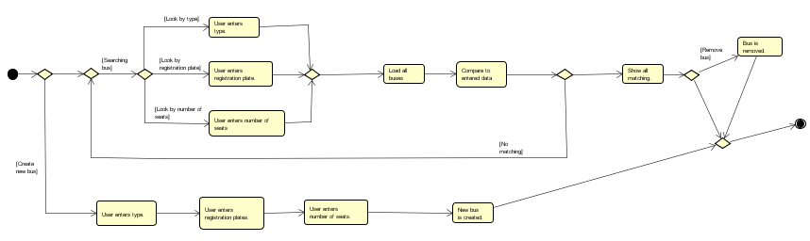**Manage buses:**

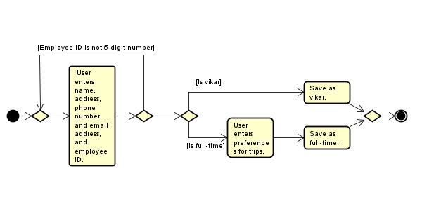**Register a new chauffeur:**

**Create a tour:**

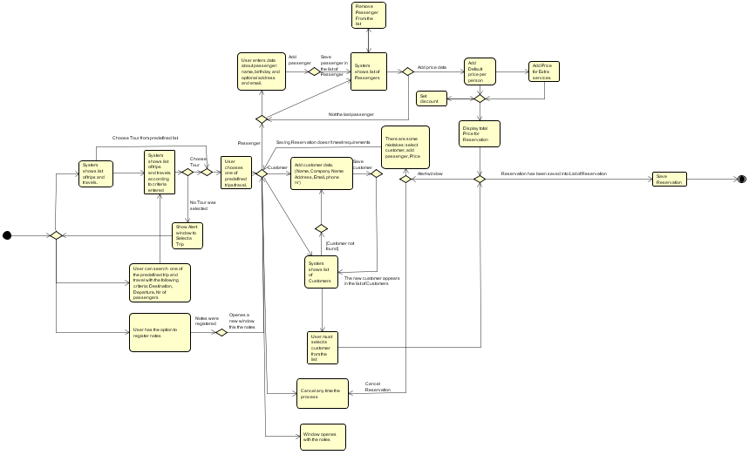**Make reservation:**

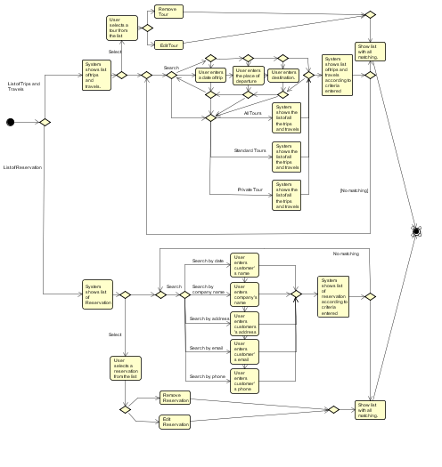**Search Reservation/Tour:**

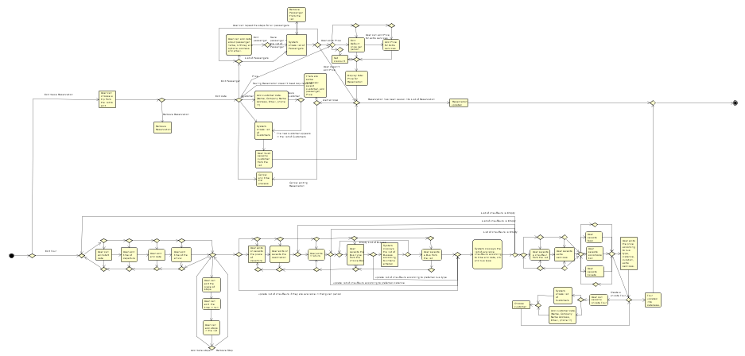**Edit Reservation/Tour:**

**Tours Overview:**

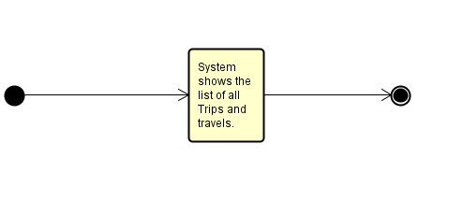

## Appendix 2 – Use Case Description

**Manage buses:**

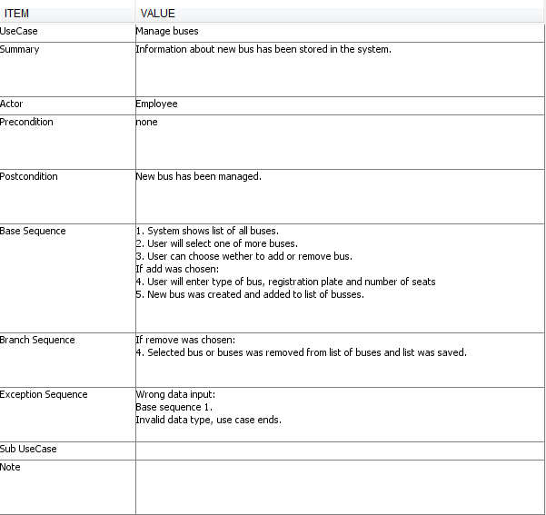

**Register a new chauffeur:**

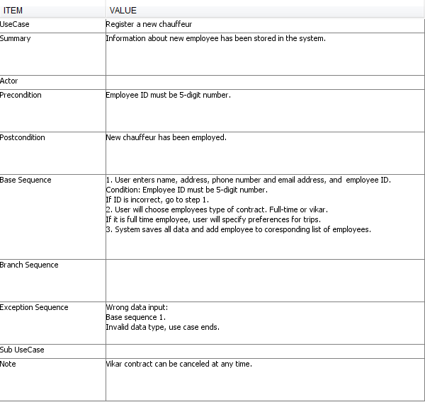

**Create a tour:**



**Make reservation:**

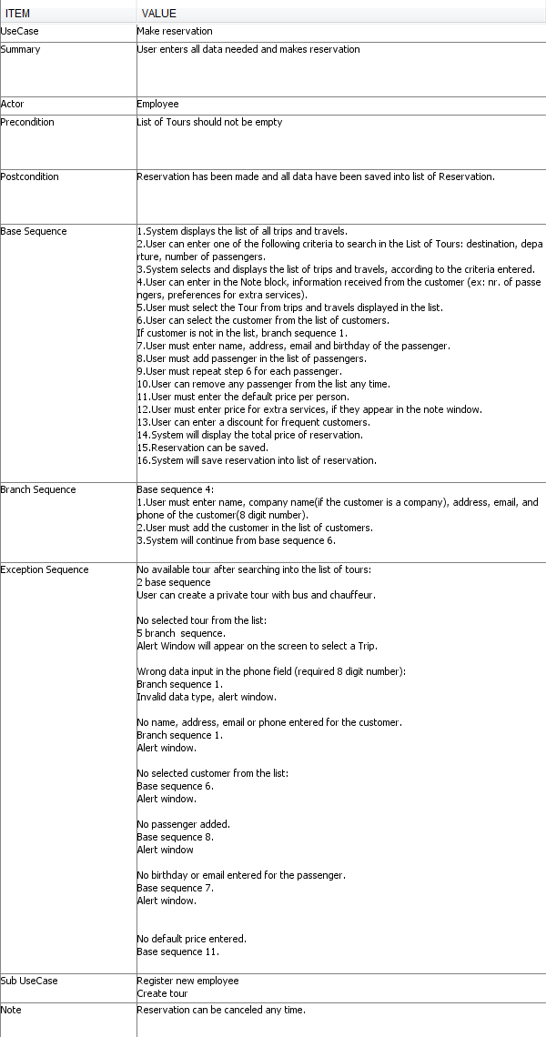

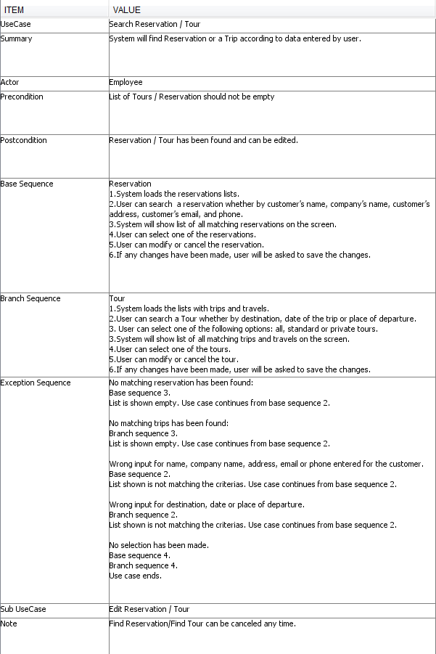**Search Reservation/Tour:**

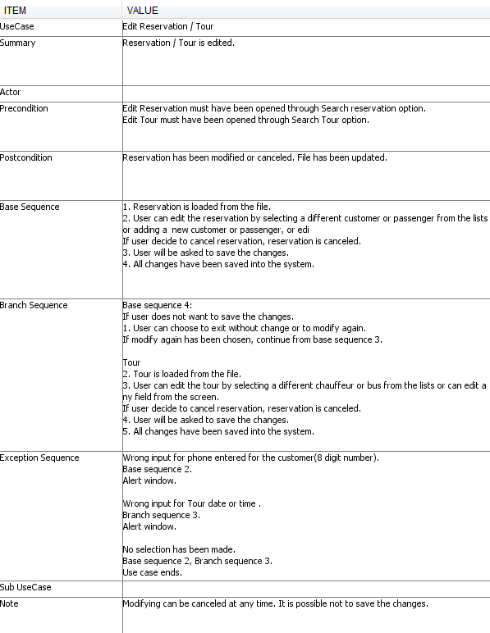**Edit Reservation/Tour:**

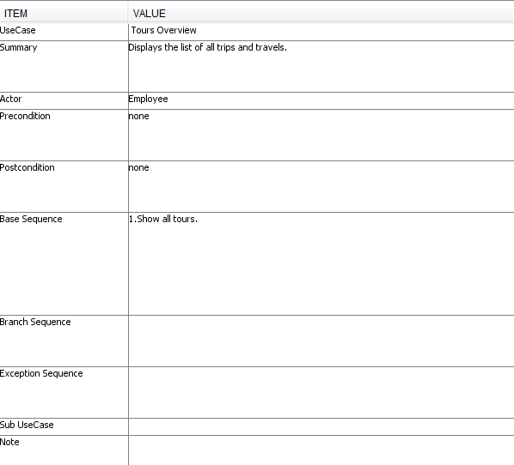**Tours Overview:**

## Appendix 3 – Class Diagram

## Appendix 4 – User Guide

**Home**

The home page is displayed when the program is opened. The Home page allows user to access Create tour, Make reservation, Find reservation / tour and displays the list of tours.

On the following pages it will be elaborated all the functions of the program.

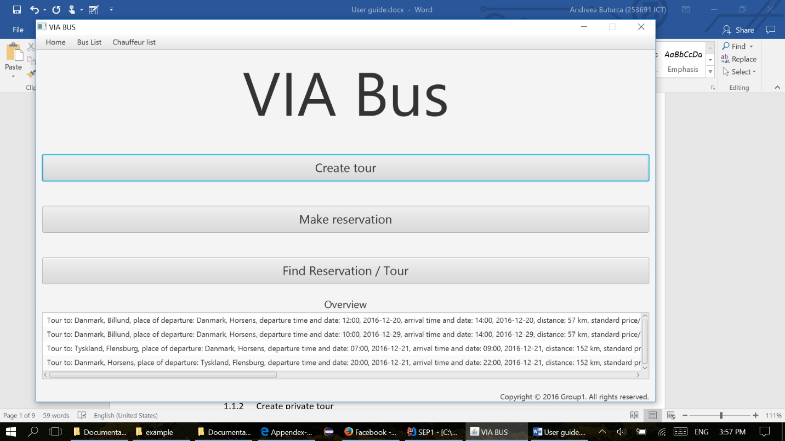

**Create tour**

**Create tour – standard**

The user must fill in all the dates about start time(format example 10:00), date of the departure (can be picked up or filled in with the following format : month/day/year: 12/01/2016), end time and date of the arrival, the departure place, destination place, distance in km, the buss type can be choosen from the list, price. The chauffeur list is sorting after user enters the date, time, and after the bus type is selected. The bus list is sorting after user selects the bus type. In order to create a new Tour, the user must select a chauffeur and a bus from the lists. In case one of the fields is not filled in, an alert window will be displayed on the screen with the name of the field that should be filled in properly

The check boxes for extra services and adding stops fields are not mandatory.

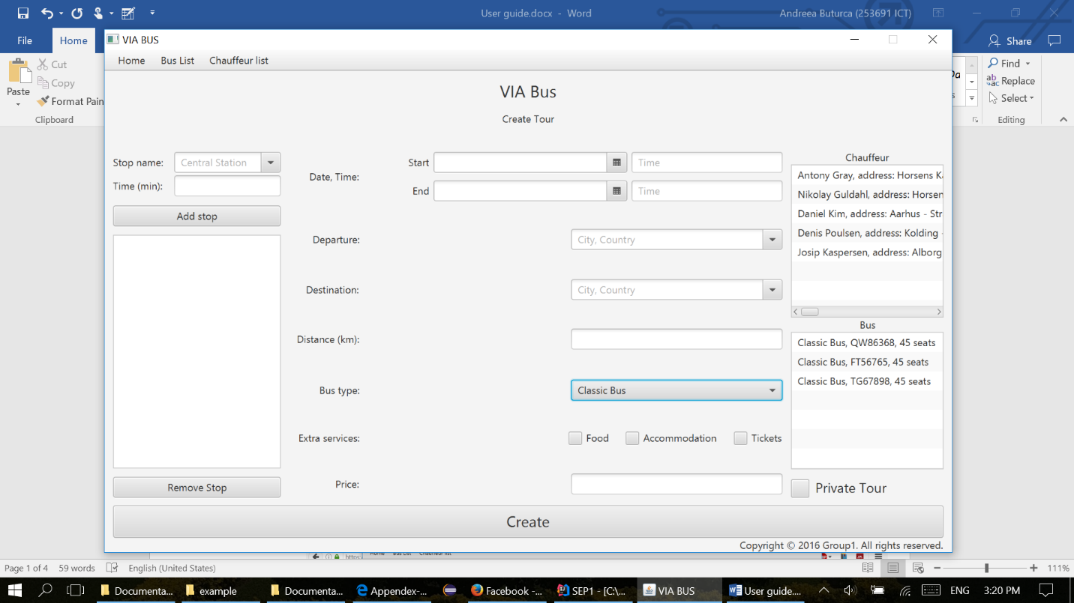

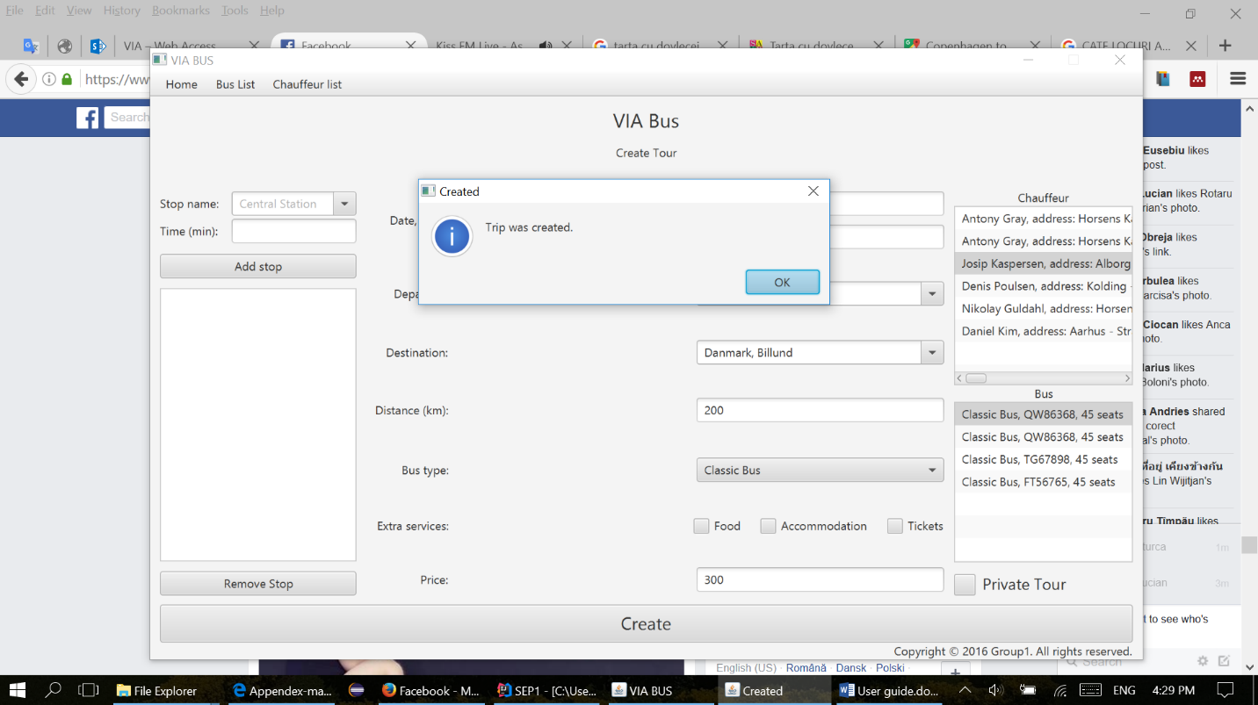In order to finish creating a new tour, the user must press the Create button and an alert window will appear on the screen, like the one displayed bellow.

**Create private tour**

If the user wants to create a private tour, he must follow the steps from Create tour, and press at the end the button Private Tour.

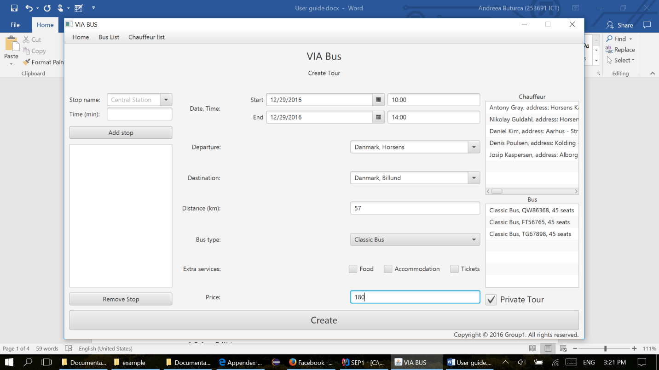



After this, another window will appear on the screen with: Fill data about customer.

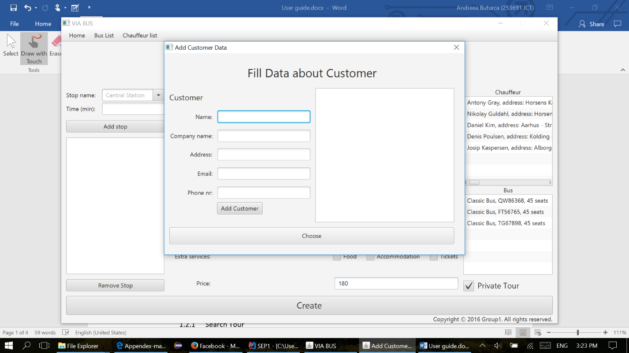This window will enable the user either to choose from the list of customers displayed on the right side of the window, or to fill in all the dates about customer: name, company name (only if the order is made by a company), address, email, and phone number

If the user doesn’t fill all the mandatory fields about the customer, an alert window will appear, like the one below, indicating which field must be filled in properly.

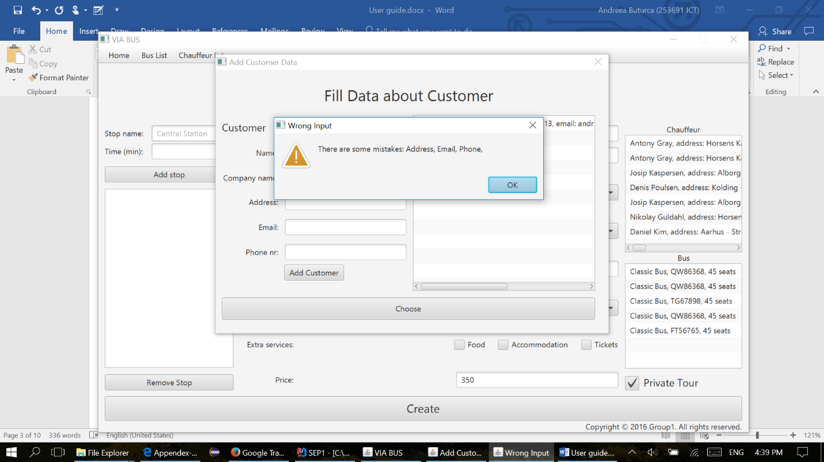

**Make reservation**

Make reservation appears in the Home tab, on the third place of the list.

**Make reservation - Search Tour**

The screen Make reservation its split in 3 sections. First section has three fields used to search in the list of tours with the following parameters: destination, departure, number of passengers. The user can pick either one, or all the fields in order to find the best tour, according to customer requirements.

Second section, it enables the user to make notes in the right side of the screen, by simply clicking on the text field and typing in. The notes will automatically appear in the next step of making reservation, with the same data, only if the user typed into the note section. Notes are a convenient way of storing information which the user needs in the workspace.

The third section of this screen is the list of the Tours displayed in the bottom of the screen. The list is updated automatically according to the searches made by the user.

Before the user presses the button Choose tour, he must select a tour from the list.



**Make reservation**

The user must select the customer, from the list of customers, wich is dispalyed under the Customer section, otherwise he must fill in all the dates about the customer, if the customer is at the first order, with the following dates: name, company name, address, email, phone number. All the fields about customer are mandatory, the field company name must be filled in, only if the order is made by a company.

The next step in “Making a reservation” is to add the passengers, one by one, by pressing Add passenger. Each passenger will appear in the list of passengers displayed under the passenger section. The fields name and birthday are mandatory. The fields address and email are used only if the customer wants to give more details to receive the newsletter.

The next step is to fill in the price per person for extra services. Remark that the field default price per person is already filled in with the price took from the selected tour field.

The user will adjust the price for extra services according to the notes he took in step 1 of “Make a reservation”. This notes appear like in the picture displayed bellow. The user can also give a discount to the customer if necessary in the field called Discount.

All the prices must be typed in per person and the total price of the reservation will appear in the Total section.

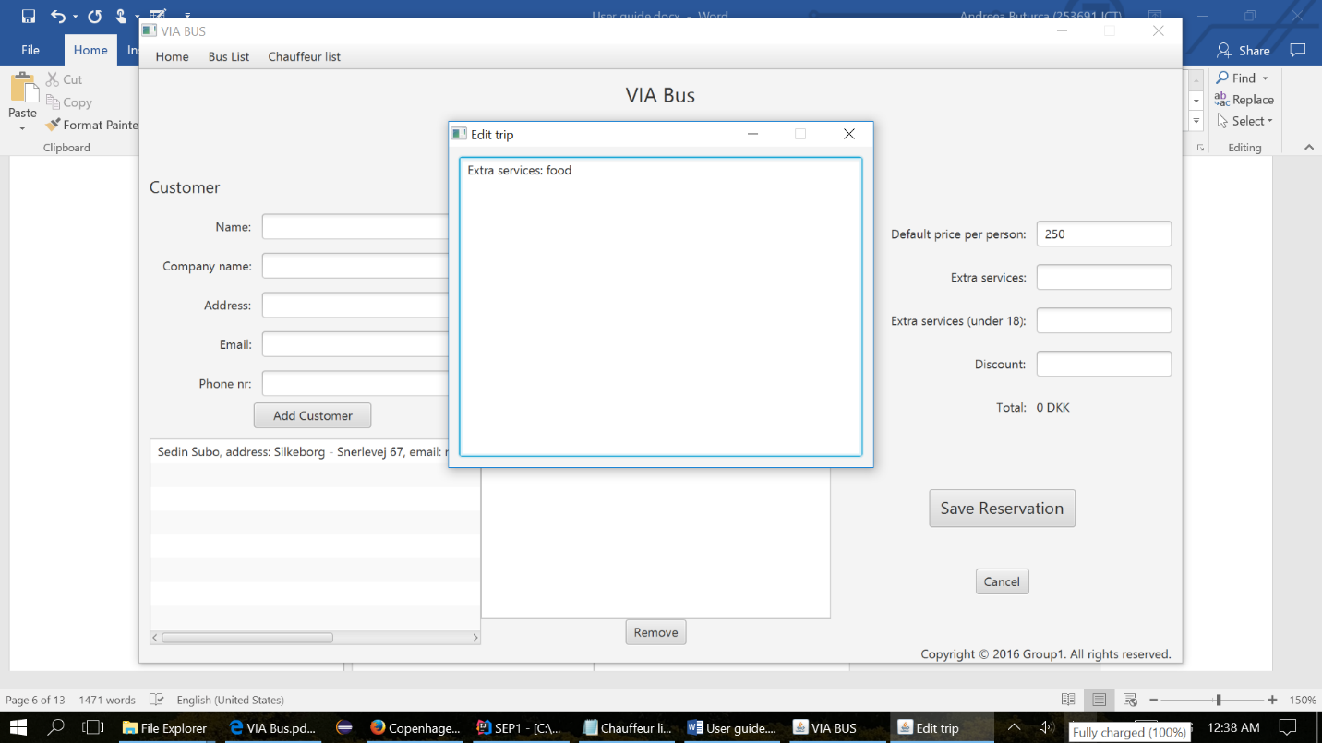

The user can any time press cancel reservation, and he will be directed to the home screen.

After all the steps enumerated above, the user can save the reservation, and an alert window will appear on the screen, which will confirm that the reservation was created.

The alert window will be exactly like the one displayed bellow.

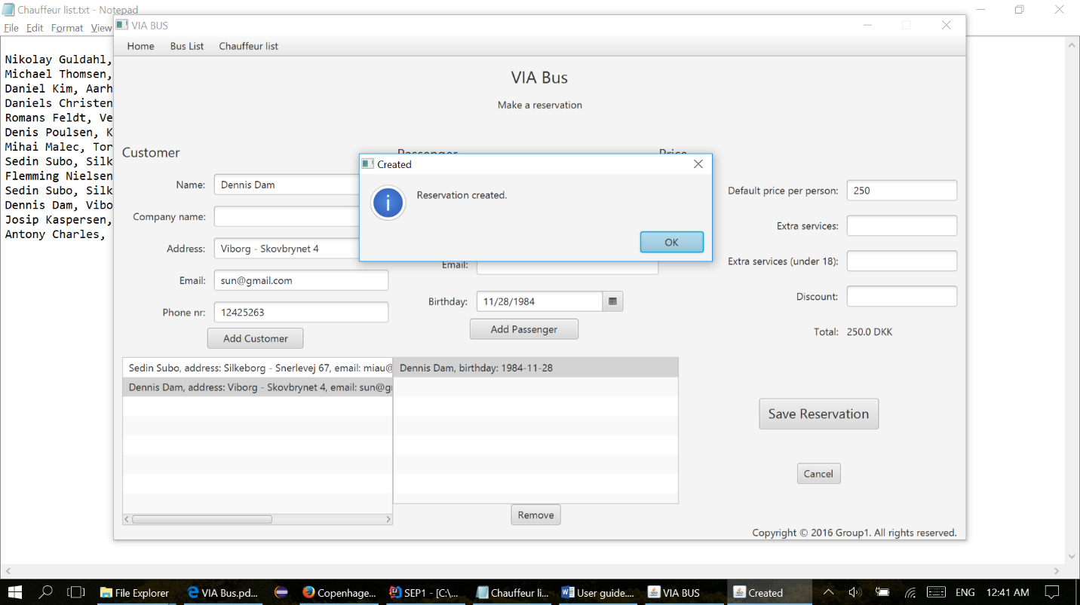

**Find Reservation/Tour**

Find Reservation/Tour appears in the Home tab, on the last place of the list. The screen it’s split in 2 sections, the left half of the page, is for Tours and the right half of the page is for Reservations.

The tour section, has three fields used to search in the list of tours with the following parameters: destination, departure, and date. The user can use either one, or all the fields in order to find the tour, according to customer requirements. And, three radio buttons for all tours, standard or private tours. The list is updated automatically according to the fields used by the user.

In order to go on edit tour or remove tour, the user must select one from the list.

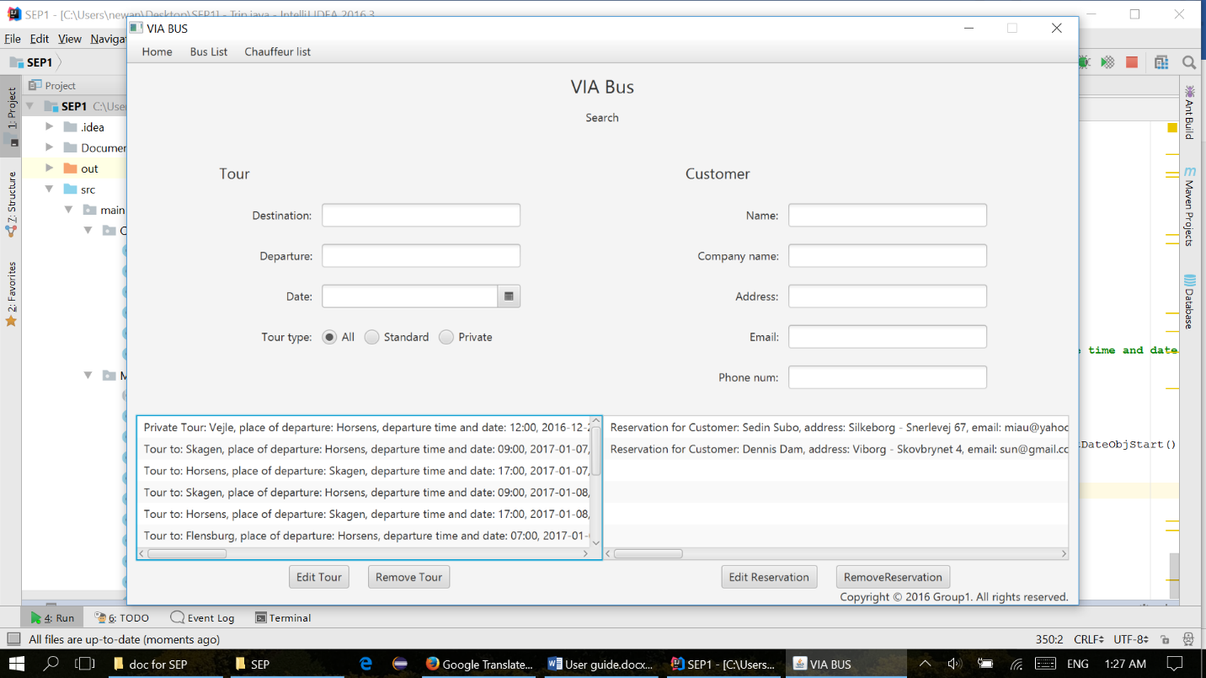

The Reservation section, has five fields used to search in the list of reservations with the following parameters about the customer that made the reservation: name, company name, address email, phone number. The user can use either one, or all the fields in order to find the right reservation. The list is updated automatically according to the fields used by the user.

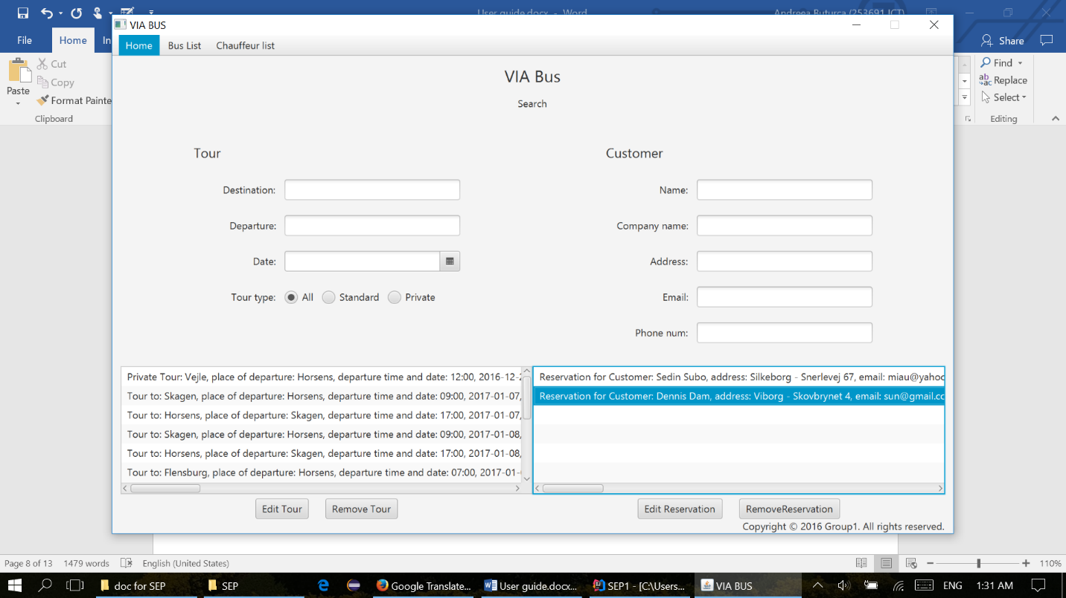In order to go on edit reservation or remove reservation, the user must select one from the list.

**Edit tour**

When the user selects edit tour, a new window will appear on the screen with the same interface like in create tour, but in this case, all the fields will be filled in with the dates from reservation selected in the previous step.

The user can edit any of the fields he wants to change, but in order to succeed, it is mandatory to select again the chauffeurs and the buss from the list.

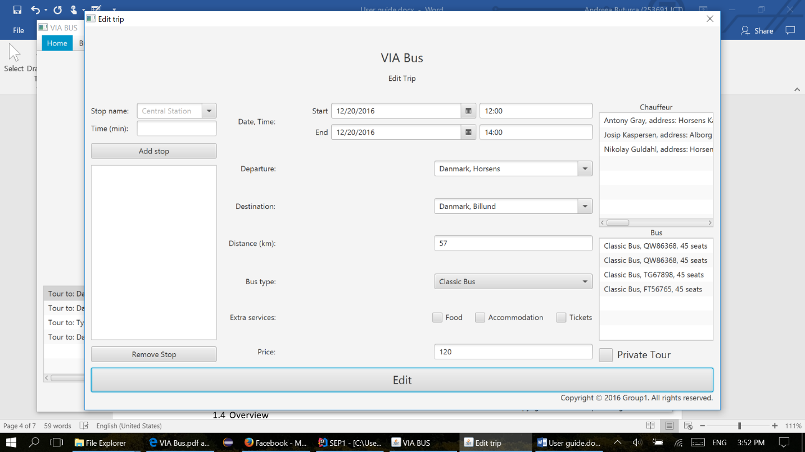

**Edit reservation**

When the user selects edit reservation, a new window will appear on the screen with the same interface like the one in Make Reservation. The user can add new customer, passengers, remove passengers or set new price or discount. To save the changes, it is mandatory to select again the customer from the list.



**Overview**

The main page shows in the bottom of the page the list of tours made by the VIA Bus company, sorted by current date.

**Bus List**

**Bus List**

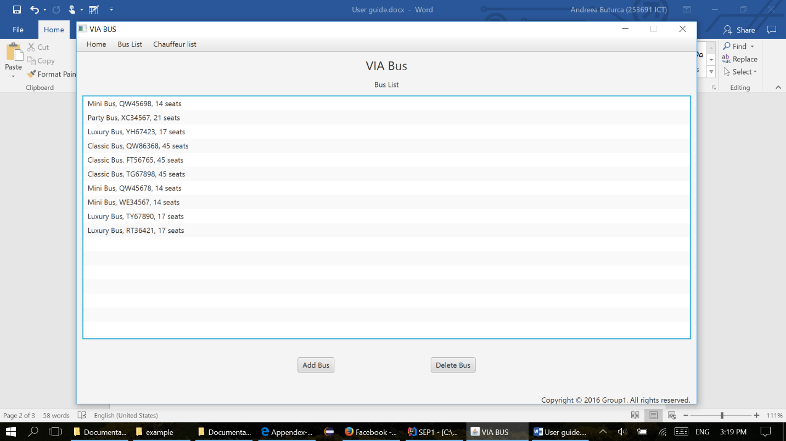The user must go on the second tab of the menu and select Bus List in order to see all busses, displayed in a list, like the one bellow.

**Add buss**

First step, the user must select one of the busses: classic bus, mini bus, party bus or luxury bus.

The second step is to add a registration plate number, which must respect to following format: 2 uppercase letters and 5 digit number (example: AS12345).

Third step: enter the number of seats, per buss.

Last step: press add button.

If one of the above steps it’s not respected, an alert window will appear on the screen, saying which field must be filled properly, otherwise a Succes window will be displayed, showing that the bus was created.

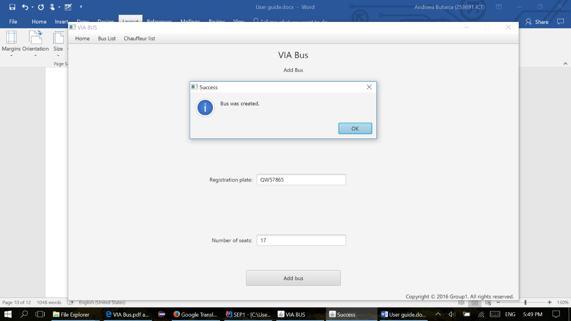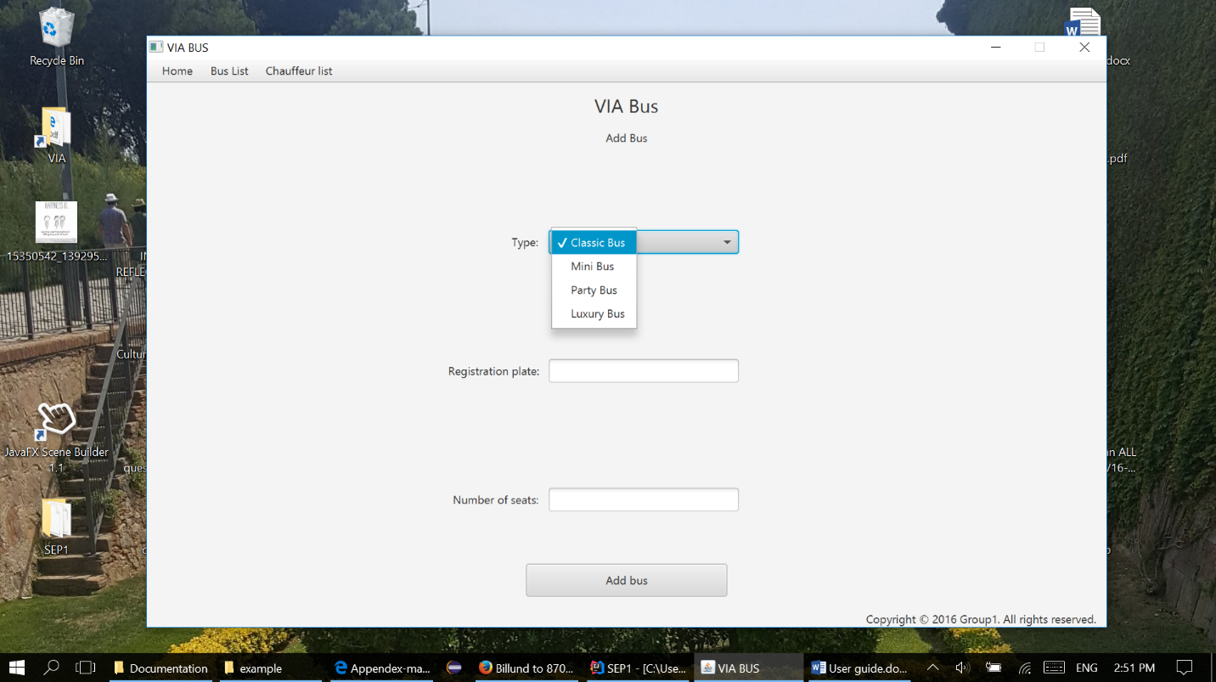

**Chauffeur List**

**Chauffeur List**

The user must go on the last tab of the menu and select Chauffeur List in order to see all chauffeurs displayed in a list

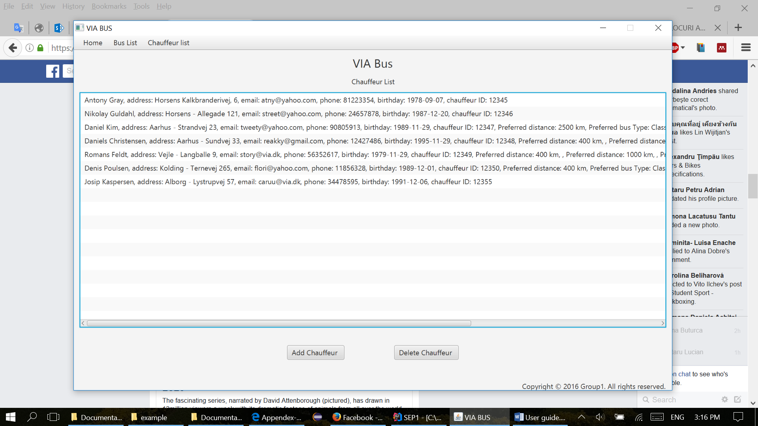

**Add chauffeur**

In the Add chauffeur, the user must fill in all the fields with the following mandatory data: name, address, email, phone number (8 digit), date of birthday(can be picked up or filled in with the following format month/day/year), employee ID (5 digit). The user can also select either one, or all the check boxes about chauffeur’s preferrences: distance and bus type. For long distance, the chauffeur prefers only tours with a distance bigger or equal with 2500 km, for medium between 400 and 2500 km and for short distance less, or equal with 400 km. If the user adds a vikar chuffeur, no preferrences are needed to be selected.

